 | MAC : Rules and Guidelines for creation of an automatic report template in Mac III | AEF00ALGO0698A00

RESTRICTED ACCESS

DISTRIBUTION : | Firm | To | Ref. | Copies | 1st page
 | AEE-C | F.Chausseron |  | 1
 | AEE-C | H.Lenormand |  | 1
 | AEA | F.Trouve |  | 1
 | AEA | T.Brennan |  | 1
 | AEE-D | A.Ratte |  | 1
 | AEP | S.Fukushima |  | 1
 | AEP | M.Tano |  | 1
 | AES | A.Brorsson |  | 1
 | AES | D. Jonsson |  | 1
 | AES | P.Anun |  | 1
 | AEA | R.Rakes |  | 1
 | AEE-C | G.Le Divenah |  |  | 1
 | AEE-C | G.Artus |  |  | 1
 | AEE-C | Secretary ship | 1

MAC: RULES and Guidelines for CREATION OF AN AUTOMATIC REPORT TEMPLATE IN Mac III

OBJECT: This document describes many rules and guidelines that shall be respected and followed in order to create an automatic report template in the Mac III tool.

SUMMARY: The guidelines and the rules described in this document should be followed to succeed creating an automatic report template, to be used in Mac III for Margin Test computations. If guidelines are not strictly to be done, not respecting the rules can lead to problems in the generation of the report, or to a bad tool behavior.

CONCLUSION: Rules and recommendations to apply in order to create an automatic report template.

Author(s) | Verified by | Approved by
Name: N.Gaborit  Date: | Name: G.Le Divenah  Date: | Name: F.Chausseron  Date:
Visa: | Visa: | Visa:
APPROVED
APPROVED
APPROVED
This document contains 67 pages.

EVOLUTION OF THE DOCUMENT

Issue Date Author Motive and nature of the modifications
A00 2008/01/14 NGA First edition, up to date for Mac III version 3.0.0.0
A00 2021/03/29 SPU Add time_event_name_filter A00 2021/08/23 CTR Add Annex 6
A00 2021/12/10 CTR Update Annex 6 with the new symbols added fro CSH info fields
CONTENTS
1 General presentation 4
2 LIST OF applicable DOCUMENTS 5
3 LIST OF REFERENCE DOCUMENTS 5
4 Edition of the Excel TEMPLATE FILE 6
4.1 Edition of a range name 6
4.2 Structure of the template 7
4.2.1 Overview 7
4.2.2 Sheets 7
4.2.3 Pages 8
4.2.4 Fixed areas 8
4.2.5 Pictures 9
4.2.6 Static cells 9
4.2.7 Arrays 10
4.2.8 Vertical divisions 11
4.2.9 Horizontal divisions 12
4.2.10 Block 13
4.2.11 Summary 19
5 Edition of the XML recipe file 21
5.1 Overview of a recipe 21
5.2 Iterators management 21
5.3 Report 22
5.3.1 Report options 22
5.3.2 User defined symbols 22
5.4 Sheet 24
5.5 Page 25
5.5.1 Pictures 26
5.5.2 Static cells 26
5.6 Array 27
5.7 Vertical division 27
5.8 Horizontal division 28
5.9 Block 29
5.9.1 Horizontal block 30
5.9.2 Vertical block 32
5.9.3 Horizontal_vertical block 33
5.10 Rules and hints 36
5.11 Summary of recipe architecture 37
6 EXAMPLE 38
7 Annex 1: List of all iterators 41
8 Annex 2: List of all iterator filters 42
9 Annex 3: List of all symbols 43
10 Annex 4: List of all style conditions 54
11 Annex 5: List of all specific styles 55
12 Annex 6: CSH Fields 56

General presentation
This document describes many rules and guidelines that can help or shall be followed in order to create an automatic margin test report in the Mac III tool.
The rules described in this document shall be followed in order to succeed in creating an automatic report template for Mac III. On the other hand, guidelines are here to ease the process or to guaranty a coherence between all the created templates. Not following these rules can lead to problems in the report generation process, or to a bad behavior of the tool.
Mac III automatic report feature allows generating a customized margin test report, on which both choices of data to generate and report presentation can be configured. Configuration is made with the use of a report template set.
A report template set is divided into two parts:
- An Excel file, called “Template”, mostly used to place the different pieces of information which will be included in the report, and to define the style of the report text options (font, style, color, size …) text alignment, merged cells, array borders,…
- An XML file, called “Recipe”, which will describe how to fill the report from template information:
  - which data to generate (it is possible to choose to not generate a column for an array in the template file)
  - the sheet, page and array iterators to repeat information generation
  - general options such as language
  - …

It is the recipe which defines the report structure and which data to write and it is the template which defines data location and formatting. The report will have the same look as the template except that in the report there are data in cells and the dimension of arrays are dynamically changed according to the data size.

To generate an automatic report, you need two files, a template file and a recipe file.
The template file is an Excel file.
The recipe file is an XML file.

There can be multiple recipes for a single template (for example one template for a calibration site report, and then a recipe for each study type).
It is recommended to use, each time it is possible, multiple recipe on the same template, rather than using different templates, as the edition of a template file is a longer and more complex task than the edition of a recipe file.

Finally, it is recommended to place both template and recipe files inside the “Templates” directory of Mac, as Margin Test report configuration interface will always select this directory when prompting for a recipe file.

This document will show you how to create a template and a recipe, in order to generate the reports you want.

LIST OF applicable DOCUMENTS

NB | DOCUMENT | REFERENCE | Company

LIST OF REFERENCE DOCUMENTS

NB | DOCUMENT | REFERENCE | Company
1 | (SRS) MACIII Report Generation | AEF00ALGO0461A03 | AEE-C

Edition of the Excel TEMPLATE FILE

Edition of a range name
The goal of the Excel template file is to select the location and the style of data to be written. In order to do so, ranges (areas in an Excel sheet) must be defined in the Excel file, and linked to a specific name, so Mac automatic report generator can find specific areas to use.
In order to do so, you need to use the “Name” feature of Excel.
To define a new name, or manage (delete, change range) existing names, go to Excel “Insert” menu, then select “Name”, and the, “Define”.
The name can also be entered, after the selection of a range, in the text box shown by the following figure.
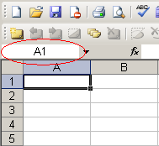
Figure 1 : Range name text box in Excel
It is possible to see the name of the selected range on this text box, as shown by the following figure.
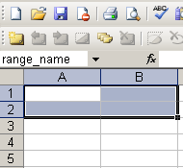
Figure 2 : Display of the selected range name

HINT: it is possible to define for the same range more than one name. This is useful when using different recipes on the same templates.

In the following of the document, any reference to a range name in Excel template will correspond to this kind of name.

Structure of the template

Overview
An Excel template file respects the following structure:

Template
→ Sheets
→ Pages
→ Fixed areas
→ Pictures
→ Static cells
→ Arrays
→ Vertical divisions
→ Horizontal divisions
→ Block
→ Static title cells *
→ Vertical dynamic title cell **
→ Horizontal dynamic title cell **
→ Dynamic cells

* : Only for vertical or horizontal blocks (one-dimension tables).
** : Only for horizontal_vertical blocks (two-dimension tables).

Sheets
The template is a list of sheets.

Please use the following names to define sheets in template: “shX” where X is the sheet index. This is not mandatory, but recommended so all templates follow the same standard.

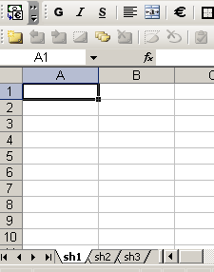
Figure 3 : A sheet named “sh1”

Pages
Each sheet contains different pages, each page being defined by a range name.

A page range name must be defined as “sheet_name.page_name”, where sheet_name is the name of the sheet where the page is defined.

Please use the following names to define pages in template: “paX” where X is the page index inside the sheet. This is not mandatory, but recommended so all templates follow the same standard.
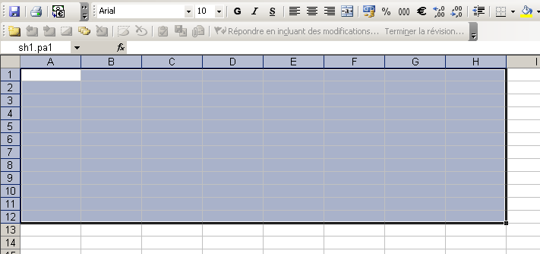
Figure 4 : Page “pa1” inside sheet sh1, with range named “sh1.pa1”

Fixed areas
Each page can contain fixed areas. A fixed area is a range, whose content will be copied to the report without any change (excepted merged cells, whose size can be extended. For example if an array is generated inside its vertical or horizontal range).

A fixed area range name must be defined as “sheet_name.page_name.fixed_areaX”, where X is the fixed area index in the page

In a page, fixed area index must start from 1, and all possible indexes must be filled from the first one to the last one (there cannot be any “hole”: for example, if fixed_area1 and fixed_area3 are defined, fixed_area2 must be defined).
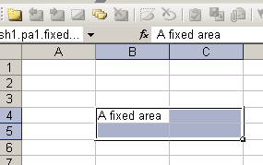
Figure 5 : A fixed area inside pa1, with range named “sh1.pa1.fixed_area1”

Pictures
A page can contain pictures. The picture will be generated from a picture file, so it is not to be included inside the template itself.
So in a template, a picture is defined by a range, indicating the area on which the picture is to be generated.

A picture must de defined by a range named “sheet_name.page_name.picture.name” where “name” is a reference which will be used in recipe to link it with a picture file.

Static cells
A page can contain static cells. A Static cell is a single cell, which can be merged or not, which will generate information from margin test results (directly from Mac or later from XML report).
A static cell is defined by a symbol. A symbol is a keyword used to select data to display on the cell. The list of all symbols used to display margin test results is available in Annex 3: List .

A static cell must be defined by a range named “sheet_name.page_name.symbol”

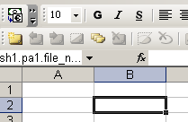
Figure 6 : A static cell inside pa1, with range named “sh1.pa1.file_name”, which will generate the name of a crash file

Arrays
A page can contain arrays.
An array is a range defined by a name.

An array must be defined by a range named “sheet_name.page_name.array_name”

Please use the following names to define arrays: “arX” where X is the array index inside the page. This is not mandatory, but recommended so all templates follow the same standard.

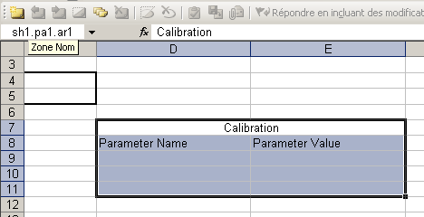
Figure 7 : An array “ar1” inside pa1, with range named “sh1.pa1.ar1”
Obviously, the range size will depend on the definition of elements of the array, described in the next sections.

Vertical divisions

An array is defined by one or more vertical divisions, in the arrangement shown by next figure.
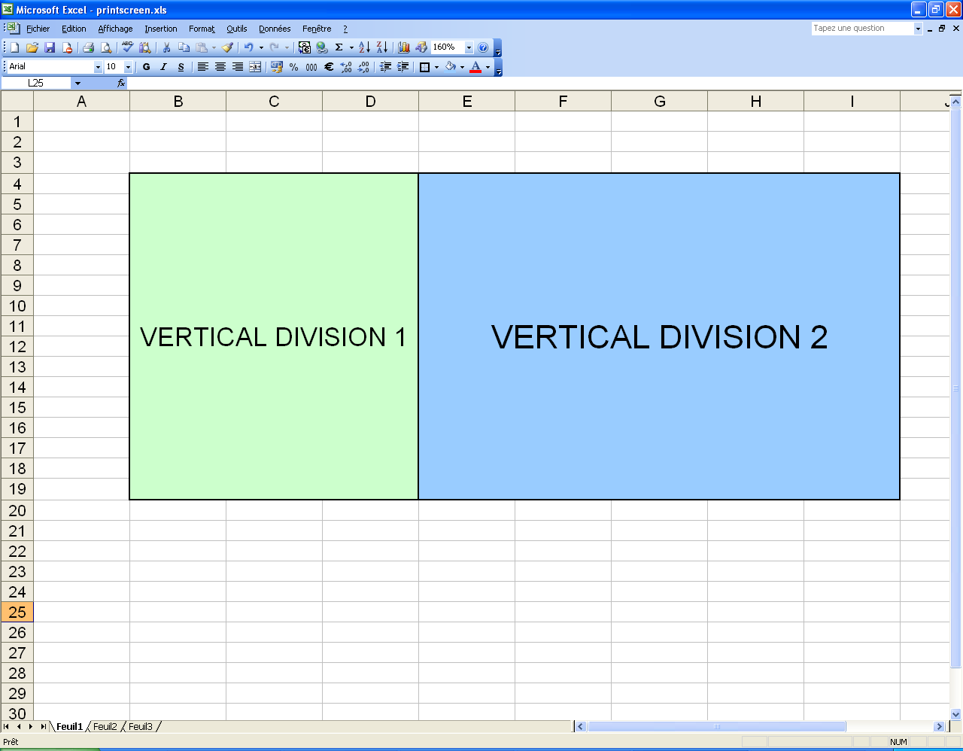

Figure 8 : Two vertical divisions of an array
A vertical division is a range defined by a name.

A vertical division must be defined by a range named “sheet_name.page_name.array_name.vertical_division_name”

Please use the following names to define vertical divisions: “vdX” where X is the vertical division index inside the array. This is not mandatory, but recommended so all templates follow the same standard.

A vertical division can contain an optional title cell. As a static cell, it is defined by a symbol.

The optional title cell of a vertical division must be its top cell, and its width must be the width of the whole vertical division.

The vertical division optional title cell range name will be sheet_name.page_name.array_name.vertical_division_name.symbol”. If “symbol” is “fixed”, the title cell will be filled by the content of the cell in the template file.
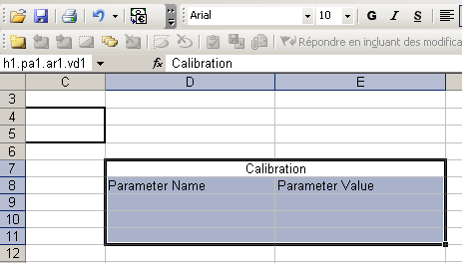
Figure 9 : A vertical division “vd1” inside array ar1, with range named “sh1.pa1.ar1.vd1”. Its title cell (the one with “Calibration” label) is named “sh1.pa1.ar1.vd1.fixed”.

Horizontal divisions

The area of a vertical division range without its title is defined by one or more horizontal divisions.
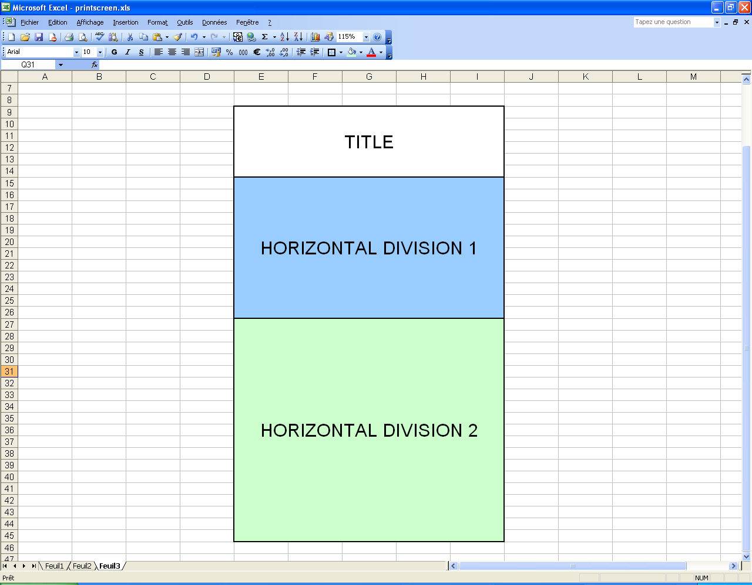

Figure 10 : Two horizontal divisions of a vertical division with a title
A horizontal division is a range defined by a name.

A horizontal division must be defined by a range named “sheet_name.page_name.array_name.vertical_division_name.horizontal_division_name”

Please use the following names to define horizontal divisions: “hdX” where X is the horizontal division index inside the vertical division. This is not mandatory, but recommended so all templates follow the same standard.

A horizontal division can contain an optional title cell. As a static cell, it is defined by a symbol.

The optional title cell of a horizontal division must be its left cell, and its height must be the height of the whole horizontal division.

The horizontal division optional title cell range name will be sheet_name.page_name.array_name.vertical_division_name.horizontal_division_name.symbol”. If “symbol” is “fixed”, the title cell will be filled by the content of the cell in the template file.
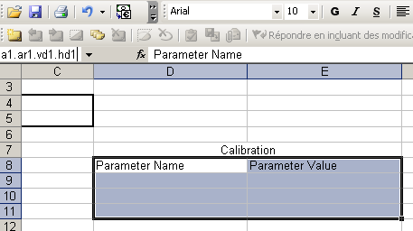
Figure 11 : A horizontal division “hd1” inside vertical division vd1, with range named “sh1.pa1.ar1.vd1.hd1” without title cell

Block

The area of a vertical division range without its title is defined by one block.
A block is the area on which array rows and/or columns will be generated dynamically. A block is defined by a range with a name.

A block must be defined by a range named “sheet_name.page_name.array_name.vertical_division_name.horizontal_division_name.block_name”

Please use the following names to define a block: “bl”. This is not mandatory, but recommended so all templates follow the same standard.

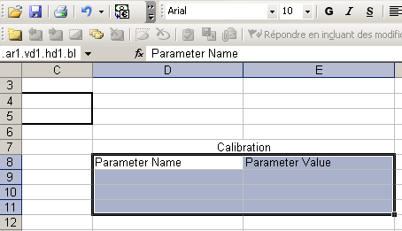
Figure 12 : A block “bl” inside horizontal division hd1, with range named “sh1.pa1.ar1.vd1.hd1.bl”
There are three kinds of blocks:
- horizontal block
- vertical block
- horizontal&vertical block

Each of them will be described in the next sections.

Horizontal block
In a horizontal block, data will be generated in rows.
A horizontal block contains title cells and dynamic cells. Title cells are optional.

title cell 1 | title cell 2 | title cell 3
dynamic cell 1 | dynamic cell 2 | dynamic cell 3
Figure 13 : A horizontal block

In a horizontal block, title cells are (if they are defined) the top cells of the block range, and they are defined by a range named “sheet_name.page_name.array_name.vertical_division_name.horizontal_division_name.block_name.title_cellX.symbol” where X is the index of the title cell from 1 (the column number of the title cell). If “symbol” is “fixed”, the title cell will be filled by the content of the cell in the template file. Title cells can be merged cells.

In a horizontal block, dynamic cells are located on the row below title cells (or first row of the block if there are none). They are defined by a range named sheet_name.page_name.array_name.vertical_division_name.horizontal_division_name.block_name.symbol”. They cannot be merged in rows.

In a horizontal block, for each dynamic cell, must be included to the block range the dynamic cell and the two cells below:
- The top cell, containing the range name of the dynamic cell, will be used for defining style of first cell of generated array.
- The middle cell will be used for defining style of inner cells of generated array.
- The bottom cell will be used for defining style of last cell of generated array.

Figure 14 : A horizontal block “bl” inside horizontal division hd1, with range named “sh1.pa1.ar1.vd1.hd1.bl”. D8 and E8 cells are title cell with range named “sh1.pa1.ar1.vd1.hd1.bl.title_cell1.fixed” and “sh1.pa1.ar1.vd1.hd1.bl.title_cell2.fixed”. D9 and E9 cells are dynamic cells with ranges named “sh1.pa1.ar1.vd1.hd1.bl.calibration_parameter_name” and “sh1.pa1.ar1.vd1.hd1.bl.calibration_parameter_value”.

Vertical block
In a vertical block, data will be generated in columns.
A vertical block contains title cells and dynamic cells. Title cells are optional.

title cell 1 | dynamic cell 1
title cell 2 | dynamic cell 2
title cell 3 | dynamic cell 3
Figure 15 : A vertical block

In a vertical block, title cells are (if they are defined) the left cells of the block range, and they are defined by a range named “sheet_name.page_name.array_name.vertical_division_name.horizontal_division_name.block_name.title_cellX.symbol” where X is the index of the title cell from 1 (the row number of the title cell). If “symbol” is “fixed”, the title cell will be filled by the content of the cell in the template file. Title cells can be merged cells.

In a vertical block, dynamic cells are located on the column at the right of title cells (or first column of the block if there are none). They are defined by a range named sheet_name.page_name.array_name.vertical_division_name.horizontal_division_name.block_name.symbol”. They cannot be merged in columns.

In a vertical block, for each dynamic cell, must be included to the block range the dynamic cell and the two cells at its right:
- The left cell, containing the range name of the dynamic cell, will be used for defining style of first cell of generated array.
- The middle cell will be used for defining style of inner cells of generated array.
- The right cell will be used for defining style of last cell of generated array.

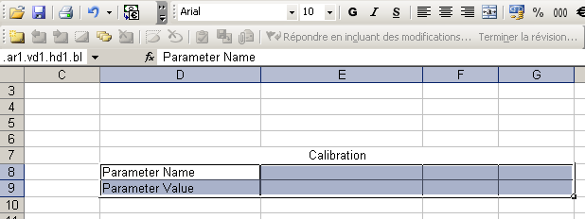
Figure 16 : A vertical block “bl” inside horizontal division hd1, with range named “sh1.pa1.ar1.vd1.hd1.bl”. D8 and D9 cells are title cell with range named “sh1.pa1.ar1.vd1.hd1.bl.title_cell1.fixed” and “sh1.pa1.ar1.vd1.hd1.bl.title_cell2.fixed”. E8 and E9 cells are dynamic cells with ranges named “sh1.pa1.ar1.vd1.hd1.bl.calibration_parameter_name” and “sh1.pa1.ar1.vd1.hd1.bl.calibration_parameter_value”.

Horizontal_vertical block
A horizontal_vertical block is a two dimensions block, where data will be generated in rows and columns.
A horizontal_vertical block contains a vertical dynamic title cell, a horizontal dynamic title cell and a dynamic cell. Title cells are optional.

 | vertical dynamic title cell
horizontal dynamic title cell | dynamic cell
Figure 17 : A horizontal_vertical block

In a horizontal_vertical block, the vertical dynamic title cell is (if it is defined) the top left cell of the block range if there is no horizontal dynamic title cell, or the cell right to the top left cell of the block range. It is defined by a range named “sheet_name.page_name.array_name.vertical_division_name.horizontal_division_name.block_name.symbol”. If “symbol” is “fixed”, the title cell will be filled by the content of the cell in the template file. Title cells can be merged cells.

In a horizontal_vertical block, if the vertical dynamic title cell is defined, must be included to the block range the vertical dynamic title cell and the two cells at its right:
- The left cell, containing the range name of the dynamic title cell, will be used for defining style of first title cell of generated array.
- The middle cell will be used for defining style of inner title cells of generated array.
- The right cell will be used for defining style of last title cell of generated array.

In a horizontal_vertical block, the horizontal dynamic title cell is (if it is defined) the top left cell of the block range if there is no vertical dynamic title cell, or the cell below the top left cell of the block range. It is defined by a range named “sheet_name.page_name.array_name.vertical_division_name.horizontal_division_name.block_name.symbol”. If “symbol” is “fixed”, the title cell will be filled by the content of the cell in the template file. Title cells can be merged cells.

In a horizontal_vertical block, if the horizontal dynamic title cell is defined, must be included to the block range the horizontal dynamic title cell and the two cells below:
- The top cell, containing the range name of the dynamic title cell, will be used for defining style of first title cell of generated array.
- The middle cell will be used for defining style of inner title cells of generated array.
- The bottom cell will be used for defining style of last title cell of generated array.

In a horizontal_vertical block, the dynamic cell is located below the vertical dynamic title cell (if it is defined), or right to the horizontal dynamic title cell (if it is defined), or in the top left of the block range (if no title cell is defined). It is defined by a range named sheet_name.page_name.array_name.vertical_division_name.horizontal_division_name.block_name.symbol”. It can be a merged cell.

In a horizontal_vertical block, the area of 3x3 cells with the dynamic cell at top left must be included to the block range: they will be used to define style of cells of the array with all 9 possible configurations (top left, top, top right, right, bottom right, bottom, bottom left, left, middle).

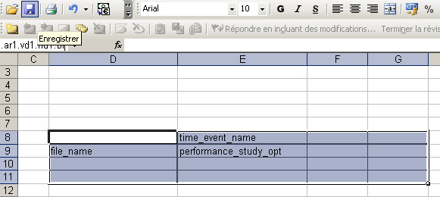
Figure 18 : A horizontal_vertical block “bl” inside horizontal division hd1, with range named “sh1.pa1.ar1.vd1.hd1.bl”. E8 cell is the vertical dynamic title cell with range named “sh1.pa1.ar1.vd1.hd1.bl.time_event_name” and D9 cell is the horizontal dynamic title cell with range named “sh1.pa1.ar1.vd1.hd1.bl.file_name”. E9 cell is the dynamic cell with range named “sh1.pa1.ar1.vd1.hd1.bl.performance_study_opt”.

Style of dynamic cells

As stated in the previous sections, a dynamic cell is always defined by 3 rows for a horizontal block, 3 columns for a vertical block, and a square of 9 cells for a horizontal&vertical block. These cells allow the definition of the style of the cell.

For a horizontal block, each of the 3 rows represents a different style, as shown by the figure below:
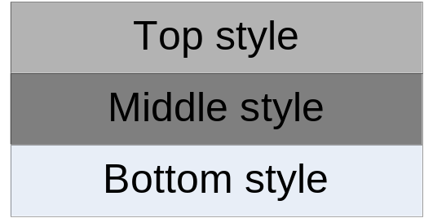

- Top style
- Middle style
- Bottom style

For example, the generation of an array which has 5 rows from these three rows gives:

 |  |  |  | Top style
 |  | Top style |  | Middle style |  | Top style
Top style |  |  |  |  |  | Middle style
Middle style |  | Middle style |  | Middle style |  | Middle style
Bottom style |  |  |  |  |  | Middle style
 |  | Bottom style |  | Middle style |  | Bottom style
 |  |  |  | Bottom style

So, data is always written with the appropriate style according to:
- If it is the first data, use the top style
- If it is the last data, use the bottom style
- For other data (neither the first, nor the last), use the middle style

For the vertical block, it is the same process and each style is defined as the following figure:
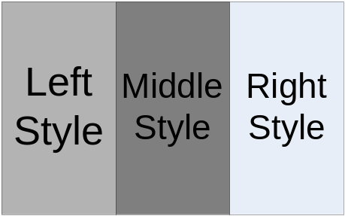

For the horizontal_vertical block, nine styles are defined. Each of the 9 definitions represents a different style, as shown by the figure below:

- Top left | - Top | - Top right
- Left | - Middle | - Right
- Bottom left | - Bottom | - Bottom right

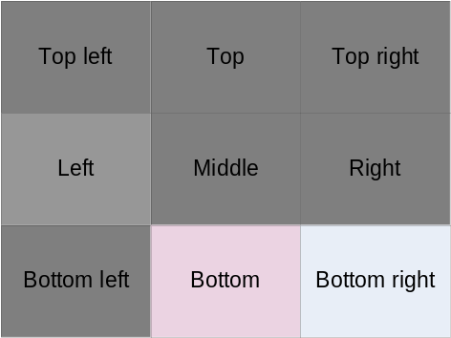

Here, the example of a horizontal_vertical block with 5 rows and 4 columns gives the following style:
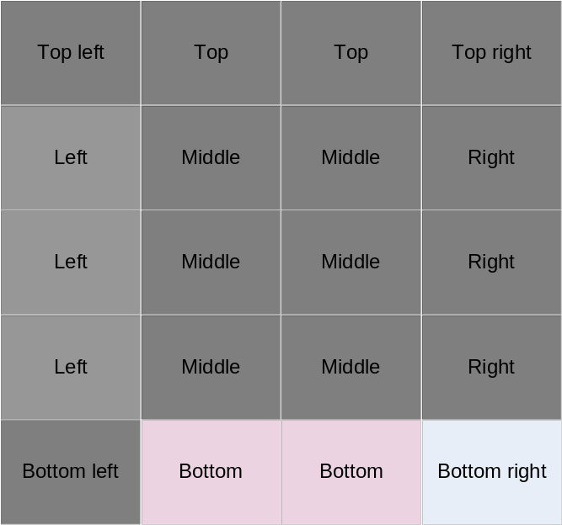

Summary

So to summarize the template structure, here are two figures to illustrate the structure of a report, the first one for the description from report to arrays, and the second one from arrays to blocks.
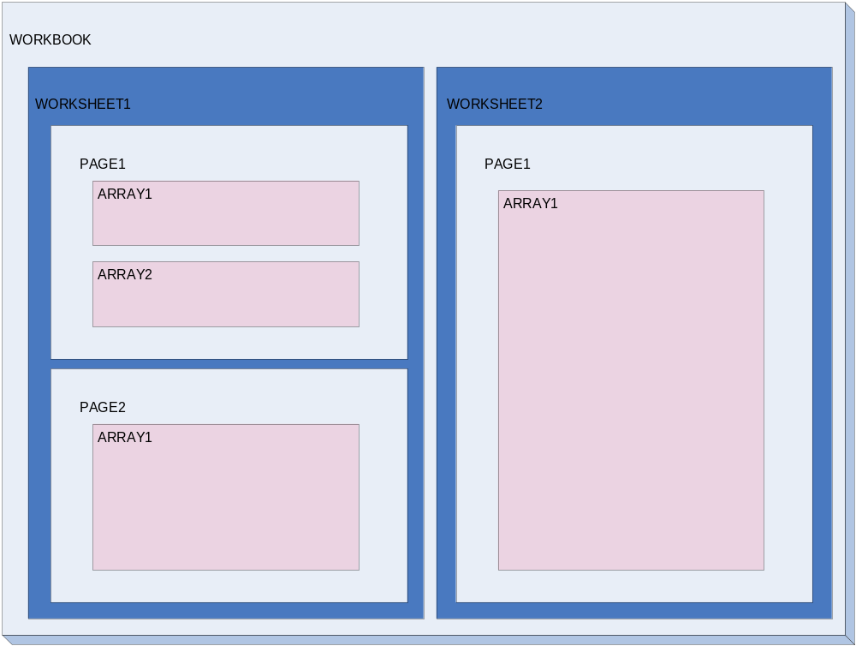 Figure 19 : Report structure
2
3
5
4
1
6
7
8
9
This table shows the names of the corresponding ranges in template:

Index | Name of range
1 | WORKSHEET1
2 | WORKSHEET1.PAGE1
3 | WORKSHEET1.PAGE1.ARRAY1
4 | WORKSHEET1.PAGE1.ARRAY2
5 | WORKSHEET1.PAGE2
6 | WORKSHEET1.PAGE2.ARRAY1
7 | WORKSHEET2
8 | WORKSHEET2.PAGE1.
9 | WORKSHEET2.PAGE1.ARRAY1

In order to build several types of arrays, here is the decomposition of an array (index 3 in previous table):

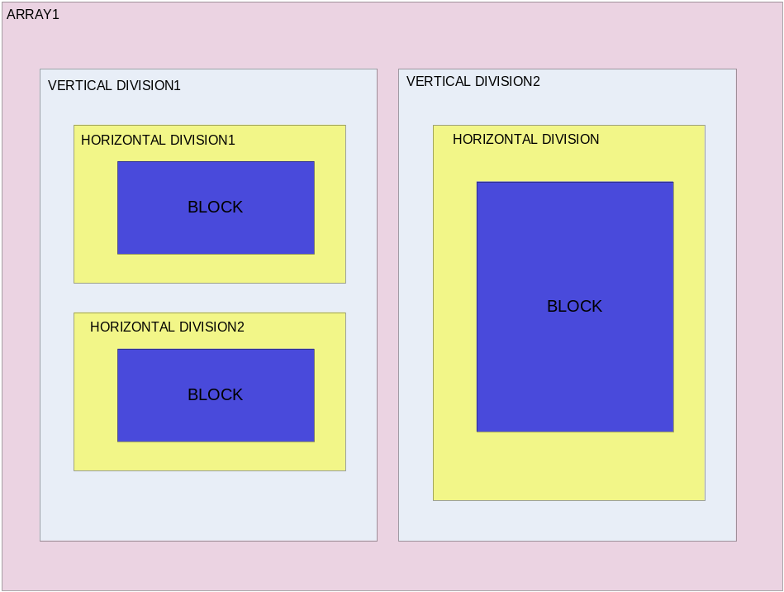
1
2
3
4
5
6
7
8
Figure 20 : Array structure

This table shows the names of the corresponding ranges in template:

Index | Name of range
1 | […].ARRAY1.VERTICALDIVISION1
2 | […].ARRAY1.VERTICALDIVISION1.HORIZONTALDIVISION1
3 | […].ARRAY1.VERTICALDIVISION1.HORIZONTALDIVISION1.BLOCK
4 | […].ARRAY1.VERTICALDIVISION1.HORIZONTALDIVISION2
5 | […].ARRAY1.VERTICALDIVISION1.HORIZONTALDIVISION2.BLOCK
6 | […].ARRAY1.VERTICALDIVISION2
7 | […].ARRAY1.VERTICALDIVISION2.HORIZONTALDIVISION1
8 | […].ARRAY1.VERTICALDIVISION2.HORIZONTALDIVISION1.BLOCK

[…] = WORKSHEET1.PAGE1

Edition of the XML recipe file

Overview of a recipe
A recipe file is an XML file which follows basically the template file structure:
MAC_REPORT_RECIPE
- Language
- Template file
→ USER_DEFINED_SYMBOL
→ SHEET
→ PAGE
- Fixed areas
→ STATIC_CELL
→ PICTURE
→ ARRAY
→ VERTICAL_DIVISION
→ HORIZONTAL_DIVISION
→ BLOCK
→ STATIC_TITLE_CELL*
→ VERTICAL_DYNAMIC_TITLE_CELL**
→ HORIZONTAL_DYNAMIC_TITLE_CELL**
→ DYNAMIC_CELL
* : Only for vertical or horizontal blocks.
** : Only for horizontal_vertical blocks.

Each bold term represents a XML node, and others XML attributes.

For the following of the document, we assume that the reader has knowledge of XML format syntax. If not, please have a look at file “ValidationRecipe.xml” in Templates directory of Mac, so you can know about the syntax.

Iterators management

Data are organised into structures which can be repeated (sheets, pages), or inside dynamic structures (arrays). In order to manage this repetition mechanism, iterators are used. An iterator is basically a counter on a data list.

The list of all used iterators is available in Annex 1: List of all iterators. Data are related to iterators, (ex file_name symbol is related to file iterator). For each symbol, related iterators are indicated in Annex 3: List of all symbols.

So, in a recipe file, nodes can be related to iterators, so excel file parts (i.e.: a sheet, a page, a block…) can be repeated to generate all data. There are therefore, in the recipe file, three attributes related to iterators, which are described now.

iterator | Action
none | Only one occurrence will be generated
name | Iterator set to “name” list (i.e.: “file” list)

iterator state | Action
init | Start at the first element (i.e.: first file)
resume | Do not reset the index. So use the last used index from the iterator.

repeat | Action
once | Only one occurrence generated, or none if the iterator is at the end of list
forever | Generate occurrences until end of list is reached

There is also the possibility to use iterator filters attributes (see all of them in Annex 2: List of all iterator filters). An iterator filter allows selecting specific elements of the list. It is possible to select (when possible) multiple filters on the same iterator, to combine two discriminations (the result will be an AND of the different filter conditions).

Report

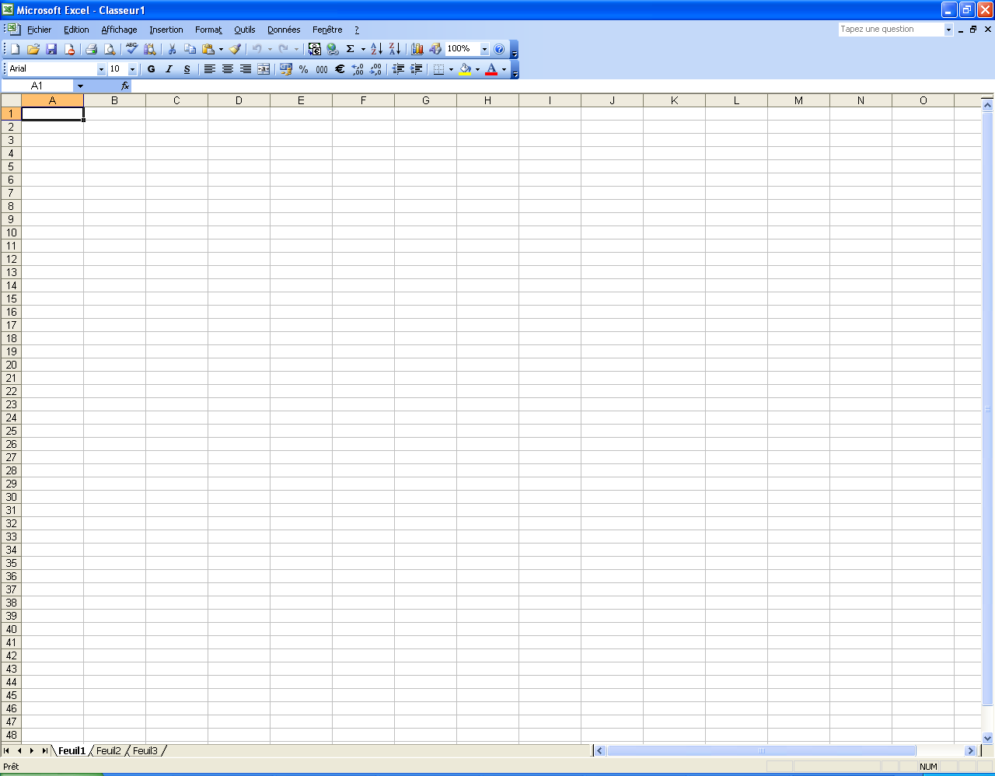
A report is an Excel file which contains several sheets.

<MAC_REPORT_RECIPE
template="Global Result Standard.xls"
language="French">
<TEMPLATE_SPECIFIC_INFORMATION/>
<SHEET/>
[…]
<SHEET/>
</MAC_REPORT_RECIPE>

Report options
Here is the list of all fields of the MAC_REPORT_RECIPE node:
Field name | Description | Possible values | Value if missing
template | The Excel template file to use with this recipe. | A correct relative path from the recipe file (ex: if the two files are in the same directory, the path will only be the template file name). | mandatory
language | The language used to write the report. | “English”, “German” or “French” | mandatory
no_firing_values_display | Indicates how to display time events no firing values. | “NF”, “zero” or “mac value” | “NF”

The language will be used to translate symbol values (ex: “Speed” will be translated by “Vitesse” if language is French).

User defined symbols
It is possible to define symbols, which are not in the used symbols list (Annex 3: List of all symbols). This is for example useful if you need for the same report two versions in different language, so you can translate a generic term with two different languages.

<USER_DEFINED_SYMBOL
name="parameter"
value="Paramètre">
/>

Here is the list of all fields of the USER_DEFINED_SYMBOL node:
Field name | Description | Possible values | Value if missing
name | A defined symbol name, which will be defined in the template. | Any name, with only lower case letters and no spaces (use “_” instead). | mandatory
value | The value generated in the report for this symbol | Any | mandatory

Example: if you need English and French reports from the same template, and need to name a cell “Parameter”, use the following:

- For English report:
<USER_DEFINED_SYMBOL name="parameter" value="Parameter"> />
- For French report:
<USER_DEFINED_SYMBOL name="parameter" value="Paramètre"> />

Sheet

Report sheets will be created from sheet nodes. A sheet can contain several pages.

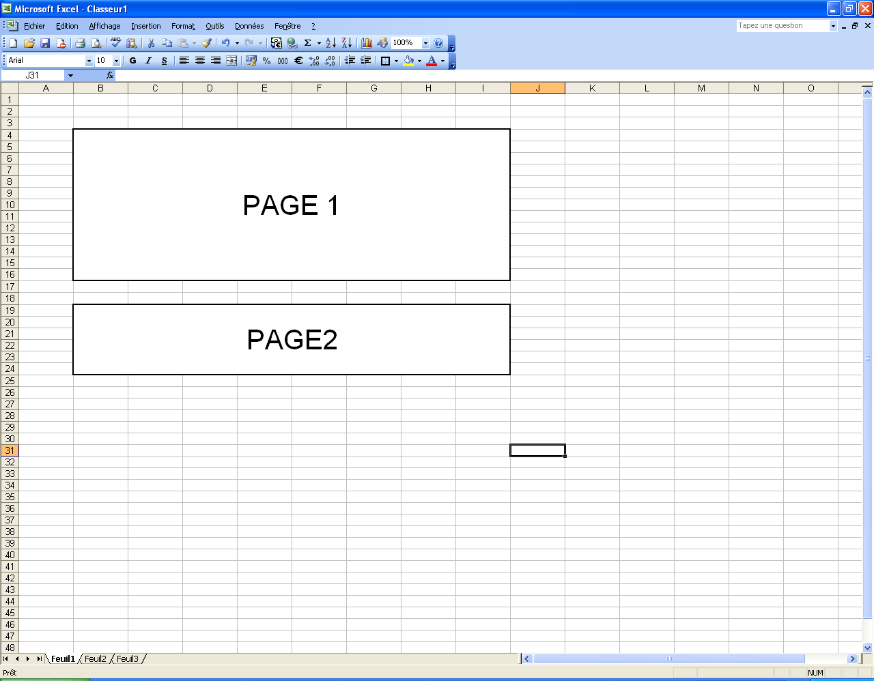
[…]
<SHEET source="sh1"
target="General Information"
iterator="none"
repeat="forever"
iterator_state="init">

<PAGE/>
[…]
<PAGE/>
<SHEET/>
[…]

The sheet is retrieved by the “source” name in the template and a new sheet is created in report with the “target” symbol name. According to “iterator_state”, and “repeat”, a sheet can be or not be repeated. For example, if the iterator of the sheet refers to the file list, there will be as many sheets as files if repeat is set to “forever” and the state to “init”. The name of each sheet is the name defined by the symbol name. The “iterator state” allows initializing or resuming the iterator. Iterator filters can also be used.

If the “target” symbol is defined as related to data (i.e.: “file_name” will give the name of the current file in file list), corresponding data will be written. If not, the name will be repeated with a suffix number. For example: if the iterator is on a file list which contains 3 files and the symbol name is “Toto”, the 3 sheets names are:
- Toto
- Toto1
- Toto2

Here is the list of all fields of the SHEET node:
Field name | Description | Possible values | Value if missing
source | Selection of a source sheet in template file. | A sheet name  in template file | mandatory
target | Choice of a name for generated sheet. The name can be static (any name), or dynamic (a symbol). | Name or symbol | mandatory
page_orientation | Sets generated sheet page orientation print setting. | “landscape” or “portrait” | use option from template source sheet
print_grid_lines | Sets generated sheet option to set if grid will be printed. | “yes” or “no” | “no”
iterator | Selects an iterator to repeat the generation of the sheet | Used iterator name  or “none” | “none”
repeat | Says if the sheet generation process will be repeated until end of iterator, or if the generation will be done only once | “forever“ or “once“ | “forever”
iterator_state | Selection of the initial state of the iterator : initialize it at beginning or resume from previous value | “init“ or “resume” | “init”
Iterator filters * | * | * | “ALL”
* : see the list of iterator filters in Annex 2: List of all iterator filters.

Page

Each page is generated from a sheet. Linked to the template structure, a page can contain several arrays, fixed areas and static cells and pictures. As a sheet, a page can be or not repeated.
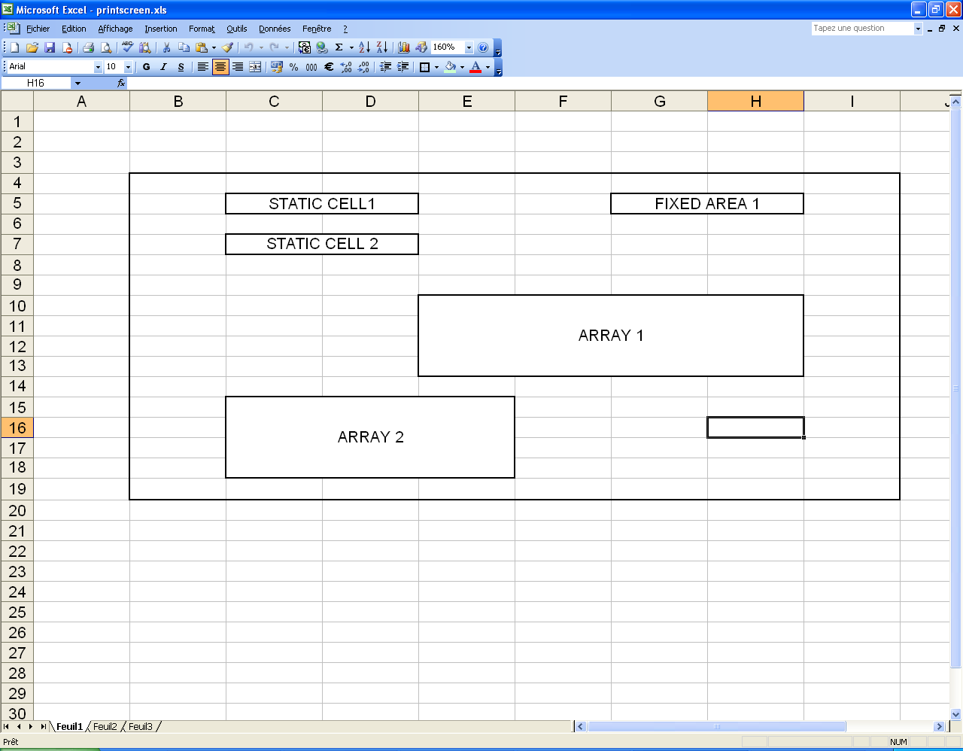
[…]
<PAGE range="pa1"
iterator="none"
repeat="forever"
fixed_areas_max_index="N"
iterator_state="init">

<PICTURE/>
[…]
<PICTURE/>
<STATIC_CELL/>
[…](i.e.: “file_name”)
<STATIC_CELL/>
<ARRAY/>
[…]
<ARRAY/>
</PAGE>
[…]

Here is the list of all fields of the PAGE node:
Field name | Description | Possible values | Value if missing
range | Selection of the page range in template sheet. | A correct range name corresponding to a full range name in template sheet.  Ex: if the sheet is named “sh1”, and the range “pa1”, this will correspond to full range in template “sh1.pa1” | mandatory
fixed_areas_max_index | Gives the maximum index of defined fixed areas in the template sheet for the page. | A integer number n, so all ranges sh1.pa1.fixed_area_i exist, where i varies from 1 to n  If n is 0, no fixed area will be read | “0”
iterator | Selects an iterator to repeat the generation of the page | Used iterator name  or “none” | “none”
repeat | Says if the page generation process will be repeated until end of iterator, or if the generation will be done only once | “forever“ or “once“ | “forever”
iterator_state | Selection of the initial state of the iterator : initialize it at beginning or resume from previous value | “init“ or “resume” | “init”
Iterator filters * | * | * | “ALL”
* : see the list of iterator filters in Annex 2: List of all iterator filters.

Pictures
A page can contain different pictures:

<PICTURE
name="picture1"
filename="picture1.jpg"
top_offset="50"
bottom_offset="50"
left_offset="100"
right_offset="200"
/>

Here is the list of all fields of the PICTURE node:

Field name | Description | Possible values | Value if missing
name | Selection of the picture name in template sheet. | A correct range name corresponding to a full range name in template sheet.  Ex: if the sheet is named “sh1”, the page “pa1”, and the name is “picture”, this will correspond to full range in template “sh1.pa1.picture” | mandatory
filename | Path to the picture file to use | A correct path, relative to the recipe file (for example if the picture is in the same directory as the recipe file, and named picture.jpg, the value will be “picture.jpg”) | mandatory
top_offset | Used to adjust picture size | Integer value (value is in pixels) | “0”
bottom_offset | Used to adjust picture size | Integer value (value is in pixels) | “0”
left_offset | Used to adjust picture size | Integer value (value is in pixels) | “0”
right_offset | Used to adjust picture size | Integer value (value is in pixels) | “0”

Static cells
A page can contain different static cells:

<STATIC_CELL name="calibration_name" />

Here is the list of all fields of the STATIC_CELL node:
Field name | Description | Possible values | Value if missing
name | Selection of the cell symbol name in template sheet. | A correct range name corresponding to a full range name in template sheet.  Ex: if the sheet is named “sh1”, the page “pa1”, and the name is “calibration_name”, this will correspond to full range in template “sh1.pa1.calibration_name” | mandatory

Array

An array is created from a page. Linked to the template structure, each array can contain several vertical divisions.

[…]
<ARRAY range="ar1"
<VERTICAL_DIVISION/>
[…]
<VERTICAL_DIVISION/>
</ARRAY>
[…]

Here is the list of all fields of the ARRAY node:
Field name | Description | Possible values | Value if missing
Range | Selection of the array range in template sheet. | A correct range name corresponding to a full range name in template sheet.  Ex: if the sheet is named “sh1”, the range “pa1”, and the array range “ar1”, this will correspond to full range in template “sh1.pa1.ar1” | mandatory

Vertical division

A vertical division is created from an array. Linked to the template structure, each vertical division can contain a title (optional) and several horizontal divisions. A vertical division can be or not repeated. If it is repeated if will be horizontally, that means that one vertical division will be on the left or on the right of another vertical division (see previous screen capture).
[…]
<VERTICAL_DIVISION
range="vd1" iterator="none"
iterator_state="init"
repeat="once"
title_cell_name="sensor_name">
<HORIZONTAL_DIVISION/>
[…]
<HORIZONTAL_DIVISION/>
</VERTICAL_DIVISION>
[…]

Here is the list of all fields of the VERTICAL_DIVISION node:
Field name | Description | Possible values | Value if missing
range | Selection of the vertical division range in template array. | A correct range name corresponding to a full range name in template sheet.  Ex: if the sheet is named “sh1”, the page “pa1”, the array “ar1”, and range is “vd1”, this will correspond to full range in template “sh1.pa1.ar1.vd1” | mandatory
title_cell_name | Symbol used to generate the title cell content. If symbol is “fixed”, the title cell content in template file will be used. | A correct range name corresponding to a full range name in template sheet.  Ex: if the sheet is named “sh1”, the page “pa1”, the array “ar1”, range is “vd1”, and title_cell_name is “fixed”, this will correspond to full range in template “sh1.pa1.ar1.vd1.fixed” | No title cell will be generated
iterator | Select an iterator to repeat the generation of the vertical division | Used iterator name  or “none” | “none”
repeat | Says if the vertical division generation process will be repeated until end of iterator, or if the generation will be done only once | “forever“ or “once“ | “forever”
iterator_state | Selection of the initial state of the iterator : initialize it at beginning or resume from previous value | “init“ or “resume” | “init”
Iterator filters * | * | * | “ALL”
* : see the list of iterator filters in Annex 2: List of all iterator filters.

Horizontal division

A horizontal division is created from a vertical division. Linked to the template structure, each horizontal division can contain a title (optional), and a block. A horizontal division can be or not repeated. If it is repeated if will be vertically, that means that one vertical division will be above or below another vertical division (see previous screen capture).
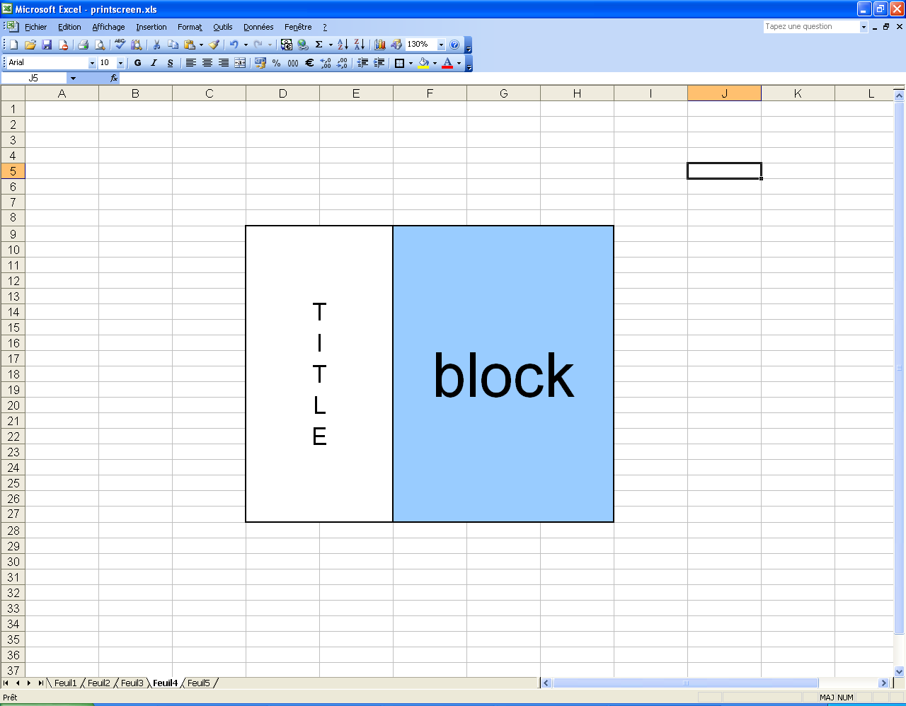

[…]
<HORIZONTAL_DIVISION
range="hd1"
iterator="none"
iterator_state="init"
repeat="forever"
title_cell_name="">
<BLOCK/>
</HORIZONTAL_DIVISION>
[…]

Here is the list of all fields of the HORIZONTAL_DIVISION node:
Field name | Description | Possible values | Value if missing
range | Selection of the horizontal division range in template vertical division. | A correct range name corresponding to a full range name in template sheet.  Ex: if the sheet is named “sh1”, the page “pa1”, the array “ar1”, the vertical division “vd1, and range is “hd1”, this will correspond to full range in template “sh1.pa1.ar1.vd1.hd1” | mandatory
title_cell_name | Symbol used to generate the title cell content. If symbol is “fixed”, the title cell content in template file will be used. | A correct range name corresponding to a full range name in template sheet.  Ex: if the sheet is named “sh1”, the page “pa1”, the array “ar1”, the vertical division “vd1, the range is “hd1”, and title_cell_name is “fixed”, this will correspond to full range in template “sh1.pa1.ar1.vd1.hd1.fixed” | No title cell will be generated
iterator | Select an iterator to repeat the generation of the horizontal division | Used iterator name  or “none” | “none”
repeat | Says if the horizontal division generation process will be repeated until end of iterator, or if the generation will be done only once | “forever“ or “once“ | “forever”
iterator_state | Selection of the initial state of the iterator : initialize it at beginning or resume from previous value | “init“ or “resume” | “init”
Iterator filters * | * | * | “ALL”
* : see the list of iterator filters in Annex 2: List of all iterator filters.

Block

A block is created from a horizontal division. Linked to the template structure, there are three kinds of blocks, according to the way we want to generate data, by rows, by columns, or both. Hence, the block can be:
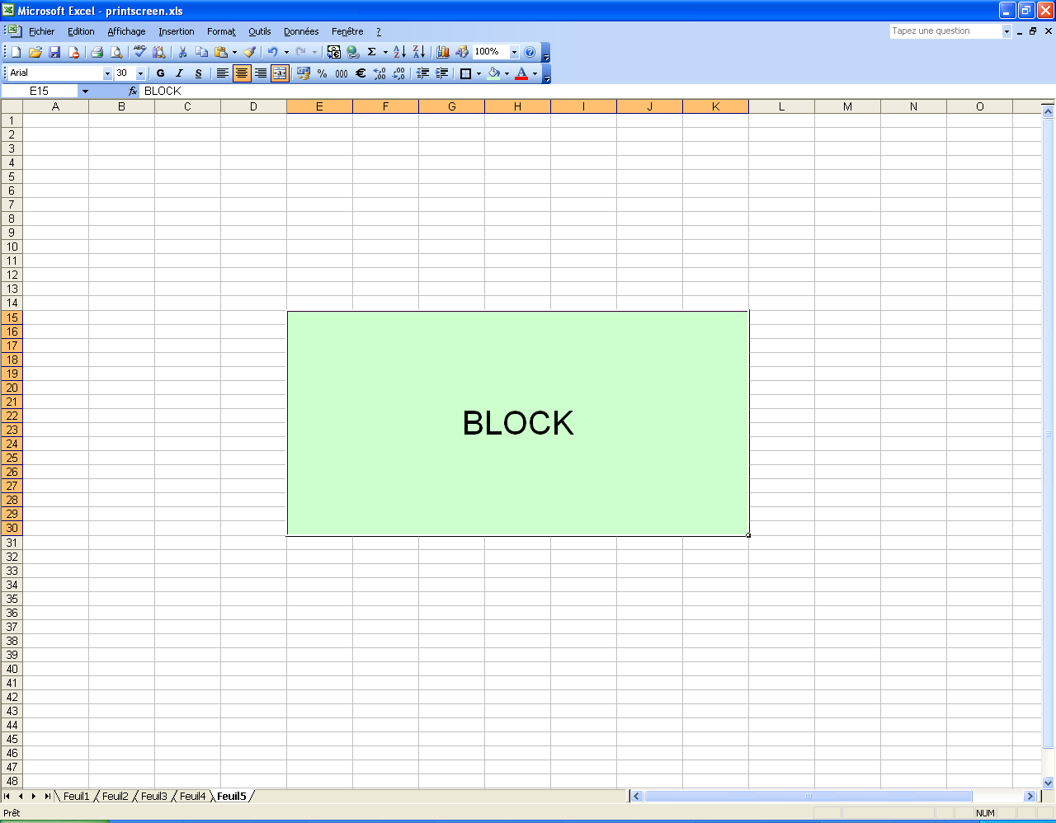
- horizontal
- vertical
- horizontal_vertical

Horizontal block

Here is the part of recipe which represents a horizontal block. Linked to the template structure, a horizontal block contains optional title cells and dynamic cells.

[…]
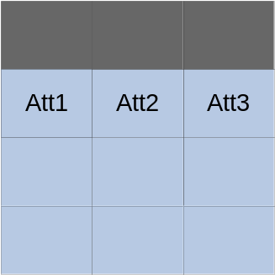<BLOCK range="bl"
type="horizontal"
iterator="electronical_parameter"
iterator_state="init"
repeat="forever">
< STATIC_TITLE_CELL/>
[…]
<STATIC_TITLE_CELL/>
<DYNAMIC_CELL/>
[…]
<DYNAMIC_CELL/>
</BLOCK>
[…]

Here is the list of all fields of the BLOCK node if it is horizontal:
Field name | Description | Possible values | Value if missing
range | Selection of the block range in template horizontal division. | A correct range name corresponding to a full range name in template sheet.  Ex: if the sheet is named “sh1”, the page “pa1”, the array “ar1”, the vertical division “vd1, horizontal divisions “hd1”, and range is “bl”, this will correspond to full range in template “sh1.pa1.ar1.vd1.hd1.bl” | mandatory
type | Block type | The type of the block. For a horizontal block, the value must be “horizontal” | mandatory
iterator | Select an iterator to repeat the generation of the block | Used iterator name  or “none” | “none”
repeat | Says if the block generation process will be repeated until end of iterator, or if the generation will be done only once | “forever“ or “once“ | “forever”
iterator_state | Selection of the initial state of the iterator : initialize it at beginning or resume from previous value | “init“ or “resume” | “init”
Iterator filters * | * | * | “ALL”
* : see the list of iterator filters in Annex 2: List of all iterator filters.

As said previously, a horizontal block is a block where data is generated in rows: the number of columns is fixed, and the number of rows depends on data size. It is composed of “two” parts:
- the pink part contains the titles of each column (optional) described in the recipe by STATIC_TITLE_CELL nodes. Titles are written only if the symbols placed in cells are not empty. In other case nothing is written.
- The blue part is the location which contains raw data. Att1, Att2 and Att3 represent the data attributes, given by a symbol to be put in cells. They are described in the recipe by DYNAMIC_CELL nodes. Other rows will be filled with data which refer to the same symbols.
For example for data of size five: five parameters (A, B, C, D and E) which have 3 attributes and three fixed columns with title, the horizontal block will be changed into the following:
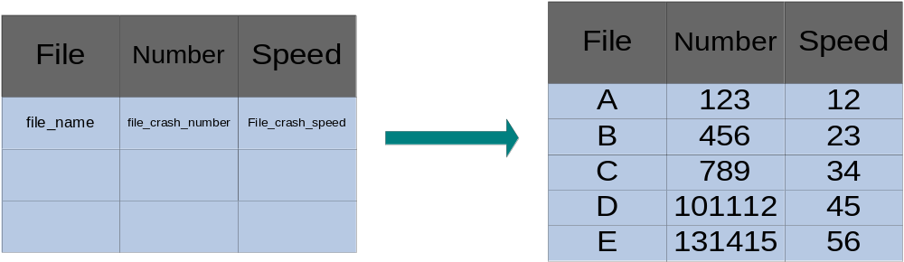
Template

Report

A STATIC_TITLE_CELL node is filled this way:
<STATIC_TITLE_CELL name="fixed" index="1" />
Here is the list of all fields of the STATIC_TITLE_CELL_NODE node if it is horizontal:
Field name | Description | Possible values | Value if missing
name | Selection of the cell symbol name in template block. If symbol is “fixed”, the title cell content in template file will be used. | A correct range name (for name) and integer (for index) corresponding to a full range name in template sheet.  Ex: if the sheet is named “sh1”, the page “pa1”, the array “ar1”, the vertical division “vd1, the horizontal division “hd1”, the block “bl”, name is “drift_name” and index is “1”, this will correspond to full range in template “sh1.pa1.ar1.vd1.hd1.bl.title_cell1.fixed” | mandatory
index | Selection of the cell title index in template block. |  | mandatory

A DYNAMIC_CELL node is filled this way :
<DYNAMIC_CELL
name="drift_name"
merge_identical_cells="yes"
style_condition="style"
/>
Here is the list of all fields of the DYNAMIC_CELL node:
Field name | Description | Possible values | Value if missing
name | Selection of the cell symbol name in template block. | A correct range name corresponding to a full range name in template sheet.  Ex: if the sheet is named “sh1”, the page “pa1”, the array “ar1”, the vertical division “vd1, the horizontal division “hd1”, the block “bl”, and name is “drift_name”, this will correspond to full range in template “sh1.pa1.ar1.vd1.hd1.bl.drift_name” | mandatory
Merge_identical_cells | Says if cells with same content will be merged | “yes” or “no” | “no”
style_condition* | Allows defining a particular style for cells respecting a selected condition. | ** | no specific style applied
* : see the list of style conditions in Annex 4: List of all style conditions.
** : see the list of specific styles in Annex 5: List of all specific styles.

Vertical block

Here is the part of recipe which represents a vertical block. Linked to the template structure, a vertical block contains optional title cells and dynamic cells.

[…]
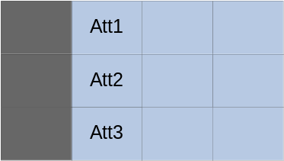<BLOCK range="bl"
type="vertical"
iterator="electronical_parameter"
iterator_state="init"
repeat="forever">
< STATIC_TITLE_CELL/>
[…]
<STATIC_TITLE_CELL/>
<DYNAMIC_CELL/>
[…]
<DYNAMIC_CELL/>
</BLOCK>
[…]

The vertical block definition (attributes of the BLOCK node, and STATIC_TITLE_CELL and DYNAMIC_CELL nodes definitions) in the recipe is the same as the horizontal block definition, excepted that type will be “vertical”.

As said previously, a vertical block is a block where data is generated in columns: the number of columns is fixed, and the number of rows depends on data size.

For example for data of size five: five parameters (A, B, C, D and E) which have 3 attributes and three fixed rows with title, the vertical block will be changed into the following:
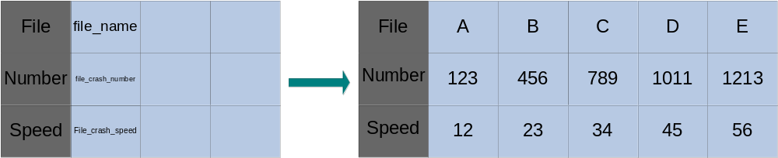
Template
Report

Horizontal_vertical block

Here is the part of recipe which represents horizontal_vertical block. Linked to the template structure, a horizontal_vertical block contains one optional horizontal dynamic title cell, one optional vertical dynamic title cell, and one dynamic cell.

[…]
<BLOCK
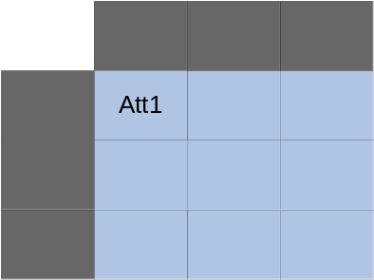range="bl"
type="horizontal_vertical"
horizontal_iterator="filel_namer"
horizontal_iterator_state="init"
vertical_iterator="electronical_parameter"
vertical_iterator_state="init"
repeat="forever">
<VERTICAL_DYNAMIC_TITLE_CELL/>
<HORIZONTAL_DYNAMIC_TITLE_CELL/>
<DYNAMIC_CELL/>
</BLOCK>
[…]

As a block is generated both in rows and columns, there are two iterators:
- a horizontal iterator
- a vertical iterator

Here is the list of all fields of the BLOCK node if it is horizontal_vertical:
Field name | Description | Possible values | Value if missing
Range | Selection of the block range in template horizontal division. | A correct range name corresponding to a full range name in template sheet.  Ex: if the sheet is named “sh1”, the page “pa1”, the array “ar1”, the vertical division “vd1, horizontal divisions “hd1”, and range is “bl”, this will correspond to full range in template “sh1.pa1.ar1.vd1.hd1.bl” | mandatory
Type | Block type | Type of the block. For a horizontal block, value must be “horizontal_vertical” | mandatory
horizontal_iterator | Selects an iterator to repeat the horizontal generation of the block | Used iterator name  or “none” | “none”
horizontal_repeat | Says if the horizontal block generation process will be repeated until end of horizontal iterator, or if the generation will be done only once | “forever“ or “once“ | “forever”
horizontal_iterator_state | Selection of the initial state of the horizontal iterator : initialize it at beginning or resume from previous value | “init“ or “resume” | “init”
horizontal_Iterator filters * | * | * | “ALL”
vertical_iterator | Select an iterator to repeat the horizontal generation of the block | Used iterator name  or “none” | “none”
vertical_repeat | Says if the horizontal block generation process will be repeated until end of horizontal iterator, or if the generation will be done only once | “forever“ or “once“ | “forever”
vertical_iterator_state | Selection of the initial state of the horizontal iterator : initialize it at beginning or resume from previous value | “init“ or “resume” | “init”
vertical_Iterator filters * | * | * | “ALL”
* : see the list of iterator filters in Annex 2: List of all iterator filters.

As said previously, a horizontal_vertical block is a block where data is generated in rows and columns, and the number of rows and columns depends on data size. This type of block is composed of “three” parts:
- the horizontal and vertical pink parts are the titles for each rows and columns (optional) respectively described in the recipe by HORIZONTAL_DYNAMIC_TITLE_CELL and VERTICAL_DYNAMIC_TITLE_CELL nodes
- the blue part is the location which contains raw data described in the recipe by the DYNAMIC_CELL node. Att1 represents data attribute given by a symbol, to be put in cells. Other cells will be filled with data which refer to the same symbol.

For example to represent a crossed attribute between five parameters in horizontal (A, B, C, D and E) and four parameters in vertical (1, 2, 3, and 4), with title, the horizontal_vertical block will be changed into the following figure 9.17:
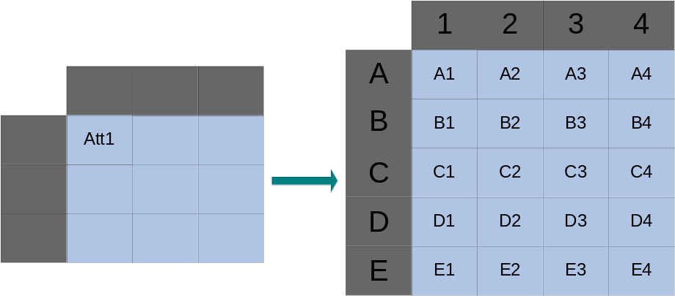
Template
Report

The HORIZONTAL_DYNAMIC_TITLE_CELL node is filled this way:
<HORIZIOTAL_DYNAMIC_TITLE_CELL name="drift_name" />
Here is the list of all fields of HORIZONTAL_DYNAMIC_TITLE_CELL node:
Field name | Description | Possible values | Value if missing
name | Selection of the cell symbol name in template block. | A correct range name corresponding to a full range name in template sheet.  Ex: if the sheet is named “sh1”, the page “pa1”, the array “ar1”, the vertical division “vd1, the horizontal division “hd1”, the block “bl”, and name is “drift_name”, this will correspond to full range in template “sh1.pa1.ar1.vd1.hd1.bl.drift_name” | mandatory

The VERTICAL_DYNAMIC_TITLE_CELL node is filled this way:
<VERTICAL_DYNAMIC_TITLE_CELL name="file_name" />
Here is the list of all fields of VERTICAL_DYNAMIC_TITLE_CELL node:
Field name | Description | Possible values | Value if missing
name | Selection of the cell symbol name in template block. | A correct range name corresponding to a full range name in template sheet.  Ex: if the sheet is named “sh1”, the page “pa1”, the array “ar1”, the vertical division “vd1, the horizontal division “hd1”, the block “bl”, and name is “file_name”, this will correspond to full range in template “sh1.pa1.ar1.vd1.hd1.bl.file_name” | mandatory

The DYNAMIC_CELL node is filled this way :
<DYNAMIC_CELL
name="bl"
style_condition="style"
/>
Here is the list of all fields of the DYNAMIC_CELL node:
Field name | Description | Possible values | Value if missing
name | Selection of the cell symbol name in template block. | A correct range name corresponding to a full range name in template sheet.  Ex: if the sheet is named “sh1”, the page “pa1”, the array “ar1”, the vertical division “vd1, the horizontal division “hd1”, the block “bl”, and name is “drift_name”, this will correspond to full range in template “sh1.pa1.ar1.vd1.hd1.bl.drift_name” | mandatory
style_condition* | Allow defining a particular style for cells respecting a selected condition. | ** | no specific style applied
* : see the list of style conditions in Annex 4: List of all style conditions.
** : see the list of specific styles in Annex 5: List of all specific styles.

Rules and hints

First, there is an order in generation of items which can be repeated:
sheet → page → vertical division → horizontal division → block
Inside a horizontal_vertical block, the order is vertical → horizontal (columns → rows)
So you have to be careful when choosing the iterators to use:

When an item is repeated with an iterator, do not use a linked iterator to this iterator (see Annex 1: List of all iterators to get the list of linked iterators for each iterator) to repeat an item inside it.
Ex: do not use sensor iterator inside a page repeated with electronic_parameter iterator.

Then, the order of declaration of some nodes in the recipe file is meaningful:

the order of declaration of the following items in recipe will be the order of generation of corresponding objects in report:
- vertical divisions
- horizontal divisions
- title and dynamic cells inside vertical or horizontal blocks

So be aware of nodes declaration order in recipe file, especially for a vertical or horizontal block declaration: BOTH title and dynamic cells must be correctly ordered, or you may have in your report data columns (or rows) not corresponding to title columns!

But this can be useful if you want to generate from the same template different recipes.
Hint: you can arrange a specific order of items generation directly in the recipe, without having to change the template.

Finally, you do not have to select everything defined inside the template in the recipe: you can choose for example to generate only a part of the columns of a horizontal block.
Hint: by selecting only desired content from the template inside the recipe, it is possible to generate different reports using different recipe with the same template, choosing for each recipe the elements to generate from the template (ex: choose only some columns from a horizontal block).

Summary of recipe architecture

MAC_REPORT_RECIPE
- template
- language
→ USER_DEFINED_SYMBOL
- name
- value
→ SHEET
- source
- target
- page_orientation
- print_grid_lines
- iterator
- iterator_state
- repeat
- iterator_filters
→ PAGE
- range
- fixed_areas_max_index
- iterator
- iterator_state
- repeat
- iterator_filters
→ PICTURE
- name
- filename
- top_offset
- bottom_offset
- right_offset
- left_offset
→ STATIC_CELL
- name
→ ARRAY
- range
→ VERTICAL_DIVISION
- range
- iterator
- iterator_state
- repeat
- iterator_filters
→ HORIZONTAL_DIVISION
- range
- iterator
- iterator_state
- repeat
- iterator_filters
→ BLOCK
- range
- type
- iterator*
- iterator_state*
- repeat*
- iterator_filters*
- horizontal_iterator **
- horizontal_iterator_state**
- horizontal_repeat**
- horizontal_iterator_filters**
- vertival_iterator**
- vertival_iterator_state**
- vertical_repeat**
- vertical_iterator_filters**
→ DYNAMIC_CELL
- name
→ STATIC_TITLE_CELL*
- name
- index
→ VERTICAL_DYNAMIC_TITLE_CELL**
- name
→ HORIZONTAL_DYNAMIC_TITLE_CELL**
- name
* : Only for vertical or horizontal blocks.
** : Only for horizontal&vertical blocks.

EXAMPLE

Here is a real example with a recipe and a template: this is a study with one time event and 5 drifts. This recipe, linked to an excel template “template.xls”, writes the report in French. The recipe contains one sheet, which contains one page, which contains one static cell, two fixed areas, and one array. The array contains one vertical division, which contains one horizontal division, which contains a horizontal block. In this block 5 parameters are taken into account:
- drift_name
- drift_min
- drift_nom
- drift_max
- drift_step

Recipe:
<?xml version="1.0" encoding="utf-8" ?>
<MAC_REPORT_RECIPE template="Template.xls"
language="French">
<SHEET source="simpleArraySheet"
target="file_name"
iterator="none"
repeat="forever"
iterator_state="init">
<PAGE range="pa1"
iterator="none"
repeat="forever"
fixed_areas_max_index="1"
iterator_state="init">
<STATIC_CELL name="time_event_name"/>
<ARRAY range="ar1"
iterator="drift"
iterator_state="init">
<VERTICAL_DIVISION range="vd1"
iterator="none"
iterator_state="init"
repeat="forever"
title_cell_name="fixed">
<HORIZONTAL_DIVISION range="hd1"
iterator="none"
iterator_state="init"
repeat="forever"
title_cell_name="">
<BLOCK range="bl"
type="horizontal"
iterator="drift"
iterator_state="init"
repeat="forever">
<STATIC_TITLE_CELL name="fixed" index="1" />
<STATIC_TITLE_CELL name="fixed" index="2" />
<STATIC_TITLE_CELL name="fixed" index="3" />
<STATIC_TITLE_CELL name="fixed" index="4" />
<STATIC_TITLE_CELL name="fixed" index="5" /> <DYNAMIC_CELL name="drift_name"/>
<DYNAMIC_CELL name="drift_min"/>
<DYNAMIC_CELL name="drift_nom"/>
<DYNAMIC_CELL name="drift_max"/>
<DYNAMIC_CELL name="drift_step"/>
</BLOCK>
</HORIZONTAL_DIVISION>
</VERTICAL_DIVISION>
</ARRAY>
</PAGE>
</SHEET>
</MAC_REPORT_RECIPE>

The template which will be loaded from the recipe is the following one:
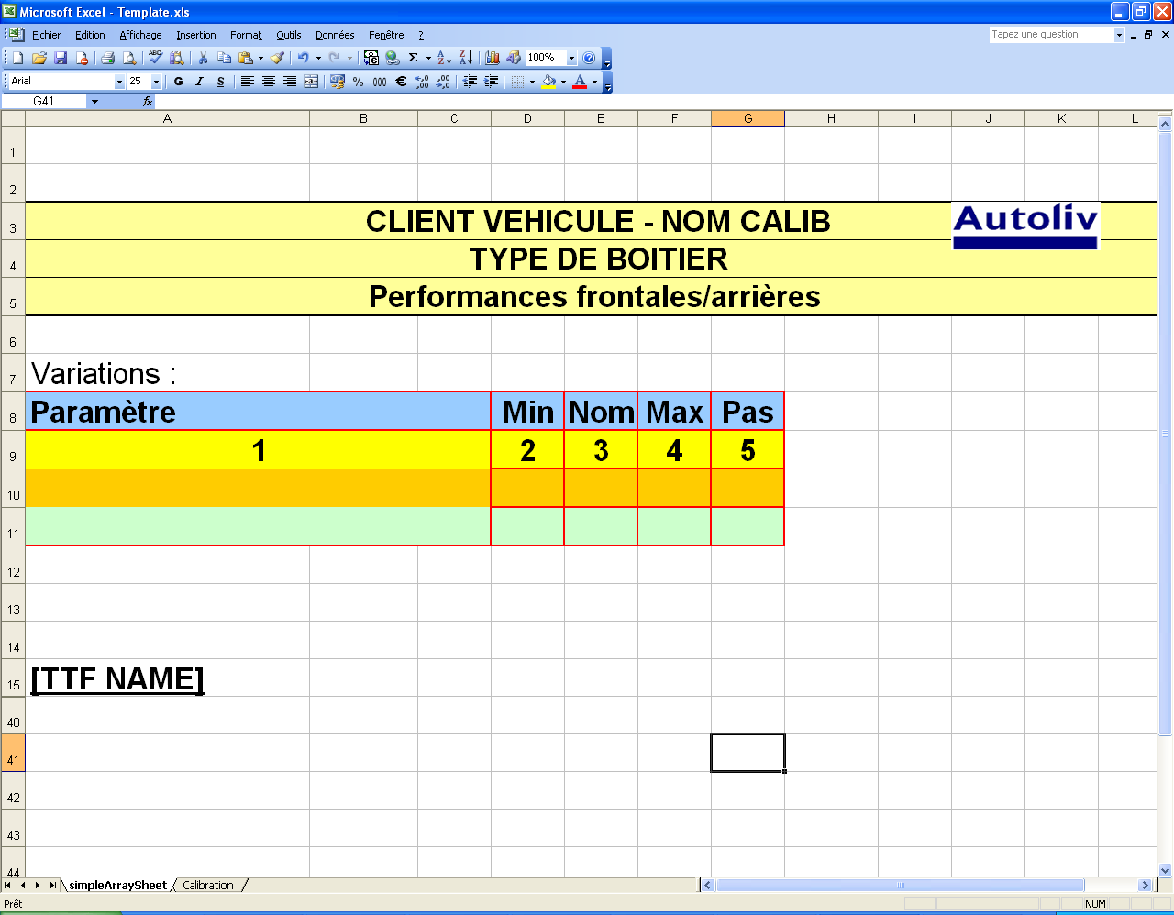

Figure 21 : Template example

Following the recipe architecture, it contains a single page inside the “simpleArraySheet” sheet. The page contains one fixed area, represented by yellow merged cells (from line 3 to line 5). It also contains a static cell (“time_event_name”), and an array (A9 to G11 cells) containing a single block from a single horizontal division from a single vertical division. The block has five title cells, and five dynamic cells to be generated, named:
- simpleArraySheet.pa1.ar1.vd1.hd1.bl.drift_name (1)
- simpleArraySheet.pa1.ar1.vd1.hd1.bl.drift_min (2)
- simpleArraySheet.pa1.ar1.vd1.hd1.bl.drift_nom (3)
- simpleArraySheet.pa1.ar1.vd1.hd1.bl.drift_max (4)
- simpleArraySheet.pa1.ar1.vd1.hd1.bl.drift_step (5)

Here is the Excel report generated from the previous recipe and template:

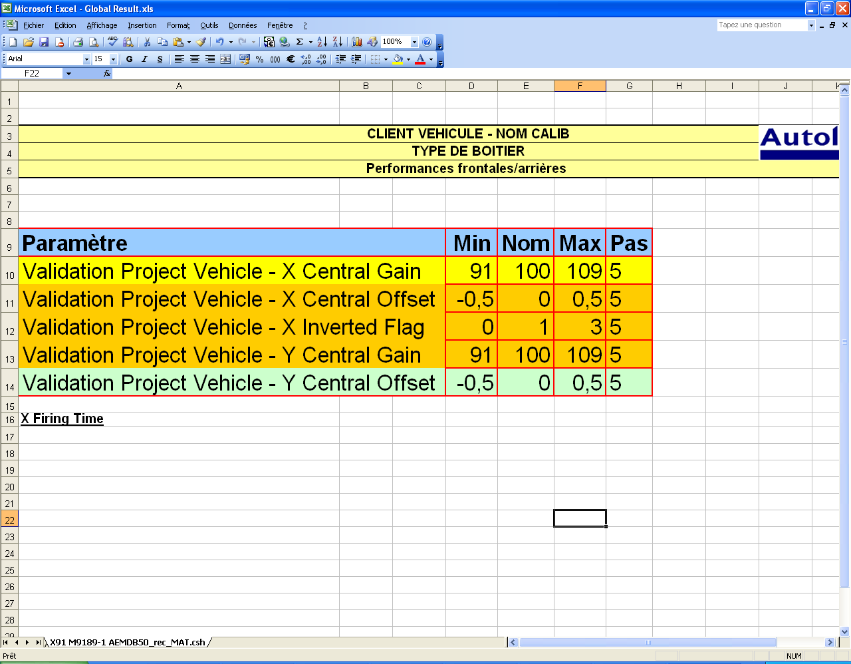
Figure 22 : Generated report from template example
If you want to look at a more complete example, please look at validation template (“ValidationTemplate.xls” and “ValidationRecipe.xml”) from Mac “Templates” directory.

Annex 1: List of all iterators

Iterator name | Iterates on | Linked iterators
multipreprocessing_item | Multipreprocessing items where files where computed
time_event | Selected time events from Margin Test
calibration_parameter | Calibration parameters defined in the project
configuration | Configuration items defined in the project (from calibration)  Ex: driver mass, vehicle speed …
display_information | Display information items defined in the project (from calibration)  Ex: Main sensor selection, Dist sensor selection …
calibration_specific_information | Specific information items defined in the project (from calibration)  EX: TTF selected, Filters activation …
file | Computed files for a multipreprocessing item | multipreprocessing_item
drift | Selected drifts for a multipreprocessing item | multipreprocessing_item
drift2 | Selected drifts for a multipreprocessing item (there is a second iterator, as some drifts results must be crossed) | multipreprocessing_item
sensor | A sensor (channel) definition for a multipreprocessing item | multipreprocessing_item
electronic_parameter | Electronic parameters for a sensor of a multipreprocessing item | multipreprocessing_item  sensor
mechanical_parameter | Mechanical parameters for a multipreprocessing item | multipreprocessing_item
acquisition_parameter | Acquisition parameters for a multipreprocessing item | multipreprocessing_item
time_event_distribution | The distribution of the computed values of a time event on a file of a multipreprocessing item | multipreprocessing_item  time_event  file
iteration * | Data (time event and drift parameters values) for all computed iterations for a multipreprocessing item | multipreprocessing_item
oscar_information_distribution ** | for a multipreprocessing item | multipreprocessing_item  time_event  file
oscar_information_used_ttf_file ** | for a multipreprocessing item | multipreprocessing_item

* : Used only for multipreprocessing items where “Enable Full Drift Distribution on Reports” has been enabled. Else “N/A” will be displayed. For now it is only used in standard report, because the high number of iterations makes usually exceed Excel number of rows or columns limits, and management of these limits in automatic report is only for now an error message (new sheets are generated with standard report).

** : Used only if OSCAR data is included to report generation.

Annex 2: List of all iterator filters

Iterator filter name | Linked iterator | Description | Possible values
multipreprocessing_item_name_filter | multipreprocessing_item | Considers only a multipreprocessing item with a specific name (there will be a single one selected, as multipreprocessing items have different names) | Any name. “ALL” will cancel the filter, accepting all multipreprocessing items.  Ex: “Performances” will only consider, if it exists, the multipreprocessing item named “Performances”
time_event_algorithm_filter * | time_event | Considers only time events, whose list of algorithms includes at least one of the specific algorithms | A list of algorithms separated by “,”. “ALL” will cancel the filter, accepting time events with any algorithm.  Ex: “Front,Side” will only consider time events whose algorithms list contains “Front” or “Side”
time_event_category_filter * | time_event | Considers only time events, whose list of categories includes at least one of the specific categories | A list of categories separated by “,”.“ALL” will cancel the filter, accepting time events with any category.  Ex: “TTF” will only consider time events whose categories list contains “TTF”
time_event_name_filter * | time_event | Considers only time events, whose name matches at least one of the specific names | A list of names separated by “,”.“ALL” will cancel the filter, accepting time events with any name.  Ex: “DR1” will only consider time events whose name is “DR1”
drift_type_filter | drift | Considers only a drift of a specified type (Mechanical, Electronic or Acquisition) | “Mechanical”, “Electronic”, “Acquisition”or “ALL”. “ALL” will cancel the filter, accepting all drifts.  Ex: “Mechanical” will only consider mechanical drifts
file_oscar_information_filter | file | Consider or not only files where OSCAR data has been generated on at least one time event | “with data”, “without data” or “ALL”  Ex: “with_data” will only consider files were OSCAR data has been generated on at least one time event
* : If both iterators are used, the selected time events will have to respect the two filters. Ex: “Front,Side” and “TTF” will consider only TTF with “Front” and “Side” algorithm AND with “TTF” category.

These filters are also available for horizontal_vertical blocks. Their names must be prefixed by “horizontal_” or “vertical_” according to the related iterator.
Ex : horizontal_drift_type_filter

Annex 3: List of all symbols
If a symbol in the template is not on this list, its name will be generated in report or its translation from TEMPLATE SPECIFIC INFORMATION node of recipe if it exists.

Symbol name | Description | Linked iterators
general_information_computation_date | Date of computations
general_information_mac_version | Mac version
general_information_project_name | Name of the project (defined in the .prt file)
general_information_customer | Customer of the project (defined in the .prt file)
general_information_unit_type | Unit type (defined in the .prt file)
general_information_ecu_version | ECU version (read from .ecu file)
general_information_algorithm_version | Algorithm version (read from Algorithm.cfg file)
general_information_displacement_unit | Unit used for displacement values
general_information_calibration_file | Path to calibration file used (.cal)
general_information_batch_mode_file | Path to batch mode file used
general_information_study_type | Study type
general_information_data_validity_message | Says if computations have been cancelled or if they have failed
general_information_xml_file_version | Version of XML report file used by the Mac tool
general_information_xml_file_path | Path of XML file (if the report has been generated from an XML file)
multipreprocessing_item_information_name | Name of multipreprocessing item | multipreprocessing_item
multipreprocessing_item_information_vehicle_file | Path to vehicle (mechanical) configuration file used for a multipreprocessing item | multipreprocessing_item
multipreprocessing_item_information_preprocessing_file | Path to preprocessing (electronic) configuration file used for a multipreprocessing item | multipreprocessing_item
multipreprocessing_item_information_acquisition_file | Path to vehicle (mechanical) configuration file used for a multipreprocessing item | multipreprocessing_item
multipreprocessing_item_information_file_list_file | Path to file list used for a multipreprocessing item | multipreprocessing_item
multipreprocessing_item_information_mechanical_computation_mode | for a multipreprocessing item, mechanical computation mode (independent or dependent sweep), corresponding to the “Do not cross mechanical drifts” option choice | multipreprocessing_item
multipreprocessing_item_information_statistical_computation_mode | for a multipreprocessing item, says if the statistical module is activated | multipreprocessing_item
multipreprocessing_item_information_iteration_number_for_one_file_valid | for a multipreprocessing item, says if the number of iterations for one file is valid, or if there are too many iterations | multipreprocessing_item
time_event_name | Name of time event | time_event
time_event_description | Description of time event | time_event
time_event_compute_displacement | Says (yes or no) if displacement is computed for its performance study
time_event_category | Category(ies) of time event (ex: “TTF”) | time_event
time_event_algorithm | Algorithm(s) of time event (ex: “Front,Side”) | time_event
time_event_oscar_name **** | OSCAR name of time event | time_event
calibration_parameter_name | Name of calibration parameter | Calibration_parameter
calibration_parameter_description | Description of calibration parameter | Calibration_parameter
calibration_parameter_unit | Unit of calibration parameter | Calibration_parameter
calibration_parameter_value | Converted value of calibration parameter | Calibration_parameter
calibration_parameter_value_hex | LSB value in hexadecimal of calibration parameter | Calibration_parameter
calibration_parameter_lock_state | Says if calibration parameter is locked or not | Calibration_parameter
calibration_parameter_no_deployment_value_hex | No deployment value of calibration parameter in hexadecimal | Calibration_parameter
calibration_parameter_neutral_value_hex | Neutral value of calibration parameter in hexadecimal | Calibration_parameter
calibration_parameter_eeprom_name | EEPROM Name of calibration parameter | Calibration_parameter
configuration_name | Name of configuration | configuration
configuration_value | Value of configuration | configuration
display_information_name | Name of display information | display_information
display_information_value | Value of display information | display_information
calibration_specific_information | Calibration specific information (items written in bottom of calibration sheet in standard report) | calibration_specific_information
mechanical_drift_parameter_name | Name of mechanical parameter | multipreprocessing_item  mechanical_parameter
mechanical_drift_parameter_description | Description of mechanical parameter | multipreprocessing_item  mechanical_parameter
mechanical_drift_parameter_unit | Unit of mechanical parameter | multipreprocessing_item  mechanical_parameter
mechanical_drift_parameter_value | Value of mechanical parameter | multipreprocessing_item  mechanical_parameter
sensor_name | name of sensor (channel in preprocessing) | multipreprocessing_item  sensor
electronic_drift_parameter_name | Name of electronic parameter | multipreprocessing_item  sensor  electronic_parameter
electronic_drift_parameter_descrion | Description of electronic parameter | multipreprocessing_item  sensor  electronic_parameter
electronic_drift_parameter_unit | Unit of electronic parameter | multipreprocessing_item  sensor  electronic_parameter
electronic_drift_parameter_value | Value of electronic parameter | multipreprocessing_item  sensor  electronic_parameter
acquisition_drift_parameter_name | Name of acquisition parameter | multipreprocessing_item  acquisition_parameter
acquisition_drift_parameter_description | Description of acquisition parameter | multipreprocessing_item  acquisition_parameter
acquisition_drift_parameter_unit | Unit of acquisition parameter | multipreprocessing_item  acquisition_parameter
acquisition_drift_parameter_value | Value of acquisition parameter | multipreprocessing_item  acquisition_parameter
drift_name | Name of drift | multipreprocessing_item  drift
drift_descripion | Description of drift | multipreprocessing_item  drift
drift_unit | Unit of drift | multipreprocessing_item  drift
drift_type | Type of drift (Mechanical, Electronic or Acquisition) | multipreprocessing_item  drift
drift_min | Minimum value of drift | multipreprocessing_item  drift
drift_nom | Nominal value of drift | multipreprocessing_item  drift
drift_max | Maximum value of drift | multipreprocessing_item  drift
drift_step | Step value of drift | multipreprocessing_item  drift
drift_points | Number of points of drift | multipreprocessing_item  drift
drift2_name | Name of drift | multipreprocessing_item  drift2
drift2_description | Description of drift | multipreprocessing_item  drift2
drift2_unit | Unit of drift | multipreprocessing_item  drift2
drift2_type | Type of drift (Mechanical, Electronic or Acquisition) | multipreprocessing_item  drift2
drift2_min | Minimum value of drift | multipreprocessing_item  drift2
drift2_nom | Nominal value of drift | multipreprocessing_item  drift2
drift2_max | Maximum value of drift | multipreprocessing_item  drift2
drift2_step | Step value of drift | multipreprocessing_item  drift2
drift_points | Number of points of drift | multipreprocessing_item  drift2
file_name | Name of file | multipreprocessing_item  file
file_has_oscar_data **** | Says if file has corresponding OSCAR data | multipreprocessing_item  file
file_oscar_scn_file_name * | Gives the corresponding .scn file (used for OSCAR data generation) | multipreprocessing_item  file
file_crash_angle | Corresponding field value from csh file, see Annex 6 for details | multipreprocessing_item  file
file_crash_speed | Corresponding field value from csh file, see Annex 6 for details | multipreprocessing_item  file
file_crash_speed_unit | Corresponding field value from csh file, see Annex 6 for details | multipreprocessing_item  file
file_crash_speed_with_unit | Corresponding field value from csh file, see Annex 6 for details | multipreprocessing_item  file
file_test_description | Corresponding field value from csh file, see Annex 6 for details | multipreprocessing_item  file
file_horizontal_coverage | Corresponding field value from csh file, see Annex 6 for details | multipreprocessing_item  file
file_leftright_hand_driven_car | Corresponding field value from csh file, see Annex 6 for details | multipreprocessing_item  file
file_obstacle_type | Corresponding field value from csh file, see Annex 6 for details | multipreprocessing_item  file
file_obstacle_mass | Corresponding field value from csh file, see Annex 6 for details | multipreprocessing_item  file
file_test_number | Corresponding field value from csh file, see Annex 6 for details | multipreprocessing_item  file
file_test_precision | Corresponding field value from csh file, see Annex 6 for details | multipreprocessing_item  file
file_test_reference | Corresponding field value from csh file, see Annex 6 for details | multipreprocessing_item  file
file_vehicle_code | Corresponding field value from csh file, see Annex 6 for details | multipreprocessing_item  file
file_vehicle_mass | Corresponding field value from csh file, see Annex 6 for details | multipreprocessing_item  file
file_vehicle_speed | Corresponding field value from csh file, see Annex 6 for details | multipreprocessing_item  file
file_vertical_coverage | Corresponding field value from csh file, see Annex 6 for details | multipreprocessing_item  file
file_side_of_impact | Corresponding field value from csh file, see Annex 6 for details | multipreprocessing_item  file
file_event_code | Corresponding field value from csh file, see Annex 6 for details | multipreprocessing_item  file
file_test_phase | Corresponding field value from csh file, see Annex 6 for details | multipreprocessing_item  file
file_simulated_event | Corresponding field value from csh file, see Annex 6 for details | multipreprocessing_item  file
file_number_of_channels | Corresponding field value from csh file, see Annex 6 for details | multipreprocessing_item  file
file_unit_type | Corresponding field value from csh file, see Annex 6 for details | multipreprocessing_item  file
file_channels_orientation | Corresponding field value from csh file, see Annex 6 for details | multipreprocessing_item  file
file_instrumentation_number | Corresponding field value from csh file, see Annex 6 for details | multipreprocessing_item  file
file_series_number | Corresponding field value from csh file, see Annex 6 for details | multipreprocessing_item  file
file_comments | Corresponding field value from csh file, see Annex 6 for details | multipreprocessing_item  file
file_catapult_test | Corresponding field value from csh file, see Annex 6 for details | multipreprocessing_item  file
file_y_position | Corresponding field value from csh file, see Annex 6 for details | multipreprocessing_item  file
file_y_position_with_unit | Corresponding field value from csh file, see Annex 6 for details | multipreprocessing_item  file
file_bumper_shield | Corresponding field value from csh file, see Annex 6 for details | multipreprocessing_item  file
file_bumper_foam | Corresponding field value from csh file, see Annex 6 for details | multipreprocessing_item  file
file_bumper_code | Corresponding field value from csh file, see Annex 6 for details | multipreprocessing_item  file
file_impactor_type | Corresponding field value from csh file, see Annex 6 for details | multipreprocessing_item  file
file_impactor_mass | Corresponding field value from csh file, see Annex 6 for details | multipreprocessing_item  file
file_impact_speed | Corresponding field value from csh file, see Annex 6 for details | multipreprocessing_item  file
file_impact_speed_unit | Corresponding field value from csh file, see Annex 6 for details | multipreprocessing_item  file
file_impact_speed_with_unit | Corresponding field value from csh file, see Annex 6 for details | multipreprocessing_item  file
file_bumper_temperature | Corresponding field value from csh file, see Annex 6 for details | multipreprocessing_item  file
file_bumper_temperature_with_unit | Corresponding field value from csh file, see Annex 6 for details | multipreprocessing_item  file
file_number_of_sensors | Corresponding field value from csh file, see Annex 6 for details | multipreprocessing_item  file
file_vehicle_manufacturer | Corresponding field value from csh file, see Annex 6 for details | multipreprocessing_item  file
file_LVE | Corresponding field value from csh file, see Annex 6 for details | multipreprocessing_item  file
file_data_units | Corresponding field value from csh file, see Annex 6 for details | multipreprocessing_item  file
file_sampling_rate | Corresponding field value from csh file, see Annex 6 for details | multipreprocessing_item  file
file_tool_version | Corresponding field value from csh file, see Annex 6 for details | multipreprocessing_item  file
file_test_date | Corresponding field value from csh file, see Annex 6 for details | multipreprocessing_item  file
performance_study_min | Minimum value of a time event from computations on a file of a multipreprocessing item | multipreprocessing_item  file  time_event
performance_study_nom | Nominal value of a time event from computations on a file of a multipreprocessing item | multipreprocessing_item  file  time_event
performance_study_max | Maximum value of a time event from computations on a file of a multipreprocessing item | multipreprocessing_item  file  time_event
performance_study_nf_presence | Percentage of non firing values of a time event from computations on a file of a multipreprocessing item | multipreprocessing_item  file  time_event
performance_study_opt_min | Minimum optimum value of a time event for a file of a multipreprocessing item | multipreprocessing_item  file  time_event
performance_study_opt_nom | Nominal optimum value of a time event for a file of a multipreprocessing item | multipreprocessing_item  file  time_event
performance_study_opt_max | Maximum optimum value of a time event for a file of a multipreprocessing item | multipreprocessing_item  file  time_event
performance_study_displacement_min | Displacement value corresponding to the minimum value of a time event from computations on a file of a multipreprocessing item | multipreprocessing_item  file  time_event
performance_study_displacement_nom | Displacement value corresponding to the nominal value of a time event from computations on a file of a multipreprocessing item | multipreprocessing_item  file  time_event
performance_study_displacement_max | Displacement value corresponding to the maximum value of a time event from computations on a file of a multipreprocessing item | multipreprocessing_item  file  time_event
performance_study_displacement_min_with_unit | Displacement value with unit corresponding to the minimum value of a time event from computations on a file of a multipreprocessing item | multipreprocessing_item  file  time_event
performance_study_displacement_nom_with_unit | Displacement value with unit corresponding to the nominal value of a time event from computations on a file of a multipreprocessing item | multipreprocessing_item  file  time_event
performance_study_displacement_max_with_unit | Displacement value with unit corresponding to the maximum value of a time event from computations on a file of a multipreprocessing item | multipreprocessing_item  file  time_event
time_event_distribution_value | One value of a time event from computed distribution on a file of a multipreprocessing item | multipreprocessing_item  file  time_event  time_event_distribution
time_event_distribution_presence | The precence (in %) of the corresponding value of a time event from computed distribution on a file of a multipreprocessing item | multipreprocessing_item  file  time_event  time_event_distribution
full_margin_study_nominal_lower_limit_behavior_change ** | State (Fire or No Fire) of time event at nominal (when all drifts are at nominal values) | multipreprocessing_item  file  time_event
full_margin_study_nominal_lower_limit_behavior_percentage ** | Percentage of the state of time event at nominal | multipreprocessing_item  file  time_event
full_margin_study_nominal_lower_limit_drift_value ** | Nominal drift value | multipreprocessing_item  file  time_event  drift2
full_margin_study_nominal_upper_limit_behavior_change ** | Behavior (Fire or No Fire) of time event at nominal (when all drifts are at nominal values), for a file of a multipreprocessing item | multipreprocessing_item  file  time_event
full_margin_study_nominal_upper_limit_behavior_percentage ** | Percentage of the behavior of time event at nominal | multipreprocessing_item  file  time_event
full_margin_study_nominal_upper_limit_drift_value ** | Nominal drift value | multipreprocessing_item  file  time_event
full_margin_study_drift_lower_limit_behavior_change ** | New behavior for a time event, if there is a behavior change at lower limit of a drift, for a file of a multipreprocessing item | multipreprocessing_item  file  time_event  drift
full_margin_study_drift_lower_limit_behavior_change_value ** | Value of the drift, when behavior changes at its lower limit | multipreprocessing_item  file  time_event  drift
full_margin_study_drift_lower_limit_behavior_percentage ** | Percentage of the new behavior at lower limit if it changed | multipreprocessing_item  file  time_event  drift
full_margin_study_drift_lower_limit_drift_value ** | For a time event, value of a drift (with iterator drift2) at behavior change in lower limit of a drift (with iterator drift), for a file of a multipreprocessing item | multipreprocessing_item  file  time_event  drift  drift2
full_margin_study_drift_upper_limit_behavior_change ** | New behavior for a time event, if there is a behavior change at upper limit of a drift, for a file of a multipreprocessing item | multipreprocessing_item  file  time_event  drift
full_margin_study_drift_upper_limit_behavior_change_value ** | Value of the drift, when the behavior changes at its upper limit | multipreprocessing_item  file  time_event  drift
full_margin_study_drift_upper_limit_behavior_percentage ** | Percentage of the new behavior at upper limit if it changed | multipreprocessing_item  file  time_event  drift
full_margin_study_drift_upper_limit_drift_value ** | For a time event, value of a drift (with iterator drift2) at behavior change in upper limit of a drift (with iterator drift), for a file of a multipreprocessing item | multipreprocessing_item  file  time_event  drift  drift2
full_margin_study_drift_summary_value ** | For a drift, a time event, and a file of a multipreprocessing item:  - If there is no behavior change, display the full range of the drift (ex: “95% - 120%” or “-1G – 1G”)  - If there is a behavior change, for each change (lower or/and upper limit), display the new behavior with the corresponding drift value (ex: “NF at 97%). | multipreprocessing_item  file  time_event  drift
full_margin_study_drift_summary_gap ** | For a drift, a time event, and a file of a multipreprocessing item:  - If there is no behavior change, display the range of the drift as a gap compared to nominal value (ex: “-5% - +20%” or “+/- 1G” )  - If there is a behavior change, for each change (lower or/and upper limit), display the new behavior with the corresponding drift value as a gap compared to nominal value (ex: “NF at -3%). | multipreprocessing_item  file  time_event  drift
full_margin_study_drift_immunity_factor ** | WORKS ONLY FOR DRIFTS WITH A NON NULL NOMINAL VALUE  For a drift, a time event, and a file of a multipreprocessing item:  - If there is no behavior limit change, display “> fx”, where f is drift maximum value divided by drift nominal value  - If there is a behavior change, use lower limit drift value if it exists or use upper limit drift value, and display “fx”, where f is the used limit drift value divided by drift nominal value | multipreprocessing_item  file  time_event  drift
full_drift_distribution_drift_value *** | For a multipreprocessing item, gives the value of a drift for a specific iteration | multipreprocessing_item  drift  iteration
full_drift_distribution_time_event_value *** | On a file of a multipreprocessing item, gives the value of the computed time event value for a specific iteration | multipreprocessing_item  file  time_event  iteration
oscar_information_min * | Minimum value, from OSCAR data, of a time event on a file of a multipreprocessing item | multipreprocessing_item  file  time_event
oscar_information_max * | Maximum value, from OSCAR data, of a time event on a file of a multipreprocessing item | multipreprocessing_item  file  time_event
oscar_information_min_state * | State of minimum value, from Oscar data, of a time event on a file of a multipreprocessing item: “correlation”, “no correlation” or “limit” | multipreprocessing_item  file  time_event
oscar_information_max_state * | State of maximum value, from Oscar data, of a time event on a file of a multipreprocessing item: “correlation”, “no correlation” or “limit” | multipreprocessing_item  file  time_event
oscar_information_general_state * | General state of OSCAR data, of a time event on a file of a multipreprocessing item: “correlation” or “no correlation” | multipreprocessing_item  file  time_event
oscar_information_nf_presence * | Percentage of non firing values of a time event from OSCAR data , of a time event on a file of a multipreprocessing item | multipreprocessing_item  file  time_event
oscar_information_distribution_value * | ONLY IF oscar_information_general_state is ”No correlation”:  One value of a time event from OSCAR data on a file of a multipreprocessing item | multipreprocessing_item  file  time_event  oscar_information_distribution
oscar_information_distribution_presence * | ONLY IF oscar_information_general_state is ”No correlation”:  The precence (in %) of the corresponding value of a time event from OSCAR data on a file of a multipreprocessing item | multipreprocessing_item  file  time_event  oscar_information_distribution
oscar_information_distribution_occurences * | ONLY IF oscar_information_general_state is ”No correlation”:  The number of occurrences corresponding value of a time event from OSCAR data on a file of a multipreprocessing item | multipreprocessing_item  file  time_event  oscar_information_distribution
oscar_information_used_ttf_file_path * | For a multipreprocessing item, name of a .ttf file used for computation of OSCAR data | multipreprocessing_item  oscar_information_used_ttf_file
multipreprocessing_item_index | Index to current value of related iterator | multipreprocessing_item
file_index | Index to current value of related iterator | multipreprocessing_item  file
drift_index | Index to current value of related iterator | multipreprocessing_item  drift
drift2_index | Index to current value of related iterator | multipreprocessing_item  drift2
calibration_parameter_index | Index to current value of related iterator | calibration_parameter
sensor_index | Index to current value of related iterator | multipreprocessing_item  sensor
electronic_parameter_index | Index to current value of related iterator | multipreprocessing_item  sensor  electronic_parameter
mechanical_parameter_index | Index to current value of related iterator | multipreprocessing_item mechanical_parameter
acquisition_parameter_index | Index to current value of related iterator | multipreprocessing_item acquisition_parameter
configuration_index | Index to current value of related iterator | configuration
display_information_index | Index to current value of related iterator | display_information
calibration_specific_information_index | Index to current value of related iterator | calibration_specific_information
time_event_index | Index to current value of related iterator | time_event
time_event_distribution_index | Index to current value of related iterator | multipreprocessing_item  time_event  file  time_event_distribution
iteration_index *** | Index to current value of related iterator | multipreprocessing_item  iteration
oscar_information_distribution_index * | Index to current value of related iterator | multipreprocessing_item  time_event  file  oscar_information_distribution
oscar_information_used_ttf_file_index * | Index to current value of related iterator | multipreprocessing_item  oscar_information_used_ttf_file
drift_complete_information | Displays for a drift  " - drift_name (drift_unit) : min = drift_min / nom = drift_nom / max = drift_max (step = drift_step / drift_points points)" | multipreprocessing_item  drift
drift_summary_information | Displays for a drift  " - drift_name: drift_min to drift_max ( step = drift_step)" | multipreprocessing_item  drift
drift_name_and_unit | Displays for a drift  "drift_name drift_unit" | multipreprocessing_item  drift
configuration_complete_information | Displays for a configuration  " - configuration_name: configuration_value" | configuration
configuration_complete_information_not_indented | Displays for a configuration  "configuration_name: configuration_value" | configuration
display_information_complete_information | Displays for a display information  " - display_information_name: display_information_value" | display_information
display_information_complete_information_not_indented | Displays for a display information  "display_information_name: display_information_value" | display_information
project_and_calibration_summary_title_1 | Displays  "C V - C"  where C is general_information_customer , V is general_information_project_name and C is the short name (file name without extension) of general_information_calibration_file
project_and_calibration_summary_title_2 | Displays  "MACIII Result for vehicle V  Calibration: C"  where V is general_information_project_name and C is the short name (file name without extension) of general_information_calibration_file
project_and_calibration_summary_title_3 | Displays "Project: P  Calibration: C"  where P is general_information_project_name and C is the short name (file name without extension) of general_information_calibration_file
performance_study_title_1 | Displays the translation of  ”general_information_study_type performances”  (ex: in French, “Front performances” will be “Performances frontales”).
calibration_name | Displays short name (file name without extension) of general_information_calibration_file
calibration_file_name | Displays file name without full path of general_information_calibration_file
preprocessing_file_name | Displays file name without full path of multipreprocessing_item_information_preprocessing_file | multipreprocessing_item
calibration_tool_and_version | Displays "MAC III V general_information_mac_version"
input_files_name_prefix **** | Display the prefix of acceptable input .ttf file names to be used to include OSCAR data.  The prefix is "general_information_project_name#calibration_name#configuration_information#"  Where calibration_name is the short name (file name without extension) of general_information_calibration_file and configuration_information is a code built from configuration data

* : Used only if OSCAR data is included to report generation.

** : Used only for multipreprocessing items where “Full Margin Feature” has been enabled. Else “N/A” will be displayed.

*** : Used only for multipreprocessing items where “Enable Full Drift Distribution on Reports” has been enabled. Else “N/A” will be displayed. For now it is only used in standard report, because the high number of iterations usually exceeds Excel limits for number of rows or columns, and management of these limits in automatic report is only for now an error message (new sheets are generated with standard report).

**** : Used if OSCAR data is included to report generation, but can still be displayed if not.

Annex 4: List of all style conditions

Style condition name | Affected symbols | Condition description
out_of_range_performance_style | performance_study_min  performance_study_nom  performance_study_max | The value is outside the optimal range, if the optimal range is defined.
out_of_range_performance_style | performance_study_nf_presence | If the value is < 100% and optimum max is NF  OR  If the value is > 0% and optimum min is defined and not NF
no_fire_performance_and_optimal_style | performance_study_min  performance_study_nom  performance_study_max | If the value and associated optimal value (min, nom or max) are both NF
change_behavior_margin_drift_value_style | full_margin_study_drift_lower_limit_behavior_change  full_margin_study_drift_lower_limit_behavior_change_value  full_margin_study_drift_lower_limit_behavior_percentage  full_margin_study_drift_lower_limit_drift_value | There is a behavior change at lower limit
change_behavior_margin_drift_value_style | full_margin_study_drift_upper_limit_behavior_change  full_margin_study_drift_upper_limit_behavior_change_value  full_margin_study_drift_upper_limit_behavior_percentage  full_margin_study_drift_upper_limit_drift_value | There is a behavior change at upper limit
change_behavior_margin_drift_value_style | full_margin_study_drift_summary_value  full_margin_study_drift_summary_gap  full_margin_study_drift_immunity_factor | There is a behavior change at lower or upper limit

Annex 5: List of all specific styles

Style name | Action
text_blue_bold | text
text_red_bold_underline | text
cell_background_red
cell_background_yellow
cell_background_black
cell_background_blue
cell_background_bluesky

Annex 6: CSH Fields
The data processing tools (MACADAM I, MACADAM II and ADAPT) store data in each CSH file, in CSH information fields. Each of these tools has a specific set of labels with different spelling, but with similar meaning, see below table for correspondance.
MAC tool is able to retrieve this data by using the corresponding Template symbols. See bolow table for mapping between MAC Template symbols, default labels and CSH fields:
MAC Template Symbol | MAC Default spelling | Field - Macadam I (1.1.4.0) | Field - Macadam II (3.0.x.x) | Field - ADAPT (2.4.x.x) | Exported to MAC Integration | Can influence simulations
file_vehicle_code | Vehicle code | Vehicle Code | Vehicle code | Vehicle Code | string VehicleCode | No
file_test_description | Test type  Test description | Crash Type | Test type | Test Type | string CrashType | No
file_side_of_impact | Side of impact  Location of impact | Side of Impact | Location of impact | Location of Impact | string SideOfImpact | No
file_test_phase | Test phase  Calibration phase | Phase of the Test | Calibration phase | Calibration Phase | string TestPhase | No
file_crash_speed  file_impact_speed_with_unit | Event speed  Impact speed  Crash speed | Crash Speed | Event speed | Event Speed | mpf_class CrashSpeed  mpf_class ImpactSpeed | Yes
file_crash_speed_unit  file_impact_speed_unit | Crash speed unit  Impact speed unit  Event speed unit | Crash Speed Unit | Event speed unit | Event Speed Unit | string CrashSpeedUnit  string ImpactSpeedUnit | No
file_event_code | Event code | Event Code | Event code | Event Code | string EventCode | No
file_test_reference | Event number  Test reference | Test Reference | Event number | Event Number | string TestReference | No
file_number_of_sensors | Number of Sensors |  | Number of sensors | Number of Sensors | NA | No
file_y_position_with_unit | Y-Position  Impact Position |  | Impact position(mm) | Impact Position (mm) | mpf_class YPosition | No
file_bumper_temperature | Bumper temperature  Temperature |  | Temperature | Temperature | mpf_class BumperTemperature | Yes
file_test_number | Abuse number  Test number |  | Abuse number | Abuse Number | string TestNumber | No
MAC Template Symbol | MAC Default spelling | Field - Macadam I (1.1.4.0) | Field - Macadam II (3.0.x.x) | Field - ADAPT (2.4.x.x) | Exported to MAC Integration | Can influence simulations
file_series_number | Abuse Series  Series number |  | Abuse series | Abuse Series | string SeriesNumber | No
file_simulated_event | Simulated event |  | Event information | Event Information | string SimulatedEvent | No
file_data_units | Data Units |  | Data units | Data Units | NA | No
file_sampling_rate | Data Sampling Rate |  | Data sampling rate | Data Sampling Rate | NA | No
file_unit_type | Unit type  Module Type | ECU | Module Type | Module Type | string UnitType | No
file_vehicle_manufacturer | Vehicle Manufacturer | ECU | Vehicle Manufacturer | Vehicle Manufacturer | NA | No
file_instrumentation_number | Instrumentation number  Instrumentation type | Instrumentation Number | Instrumentation type | Instrumentation Type | long InstrumentationNumber | No
NA |  | File Format | File Format |  | NA | No
NA |  | File Naming Convention | File Naming Convention |  | NA | No
file_number_of_channels | Number of channels | Number of Channels | Number of Channels | Number of Channels | string NumberOfChannels | No
file_channels_orientation | Channels orientation | Channel Orientation | Channels Orientation | Channel Orientation | string ChannelsOrientation | No
file_vehicle_speed | Vehicle speed | Vehicle Speed | Vehicle Speed | Vehicle Speed | mpf_class VehicleSpeed | Yes
file_crash_angle | Crash angle | Crash Angle | Crash Angle | Crash Angle | mpf_class CrashAngle | No
file_test_precision | Test precision | Precision on the Crash Type | Test Precision | Test Precision | string PreciseCrashType | No
NA |  |  | Test mode |  | NA | No
file_horizontal_coverage | Horizontal coverage | Horizontal Covering | Horizontal Coverage | Horizontal Coverage | mpf_class HorizontalCovering | No
file_vertical_coverage | Vertical coverage | Vertical Covering | Vertical Coverage | Vertical Coverage | mpf_class VerticalCovering | No
file_leftright_hand_driven_car | Left-Right hand driven vehicle | Left Hand/Right Hand Driven Car | Left-Right Hand Driven Vehicle | Left-Right Hand Driven Vehicle | string HandDrivenCar | No
file_vehicle_mass | Vehicle mass | Vehicle Mass | Vehicle Mass | Vehicle Mass | mpf_class VehicleMass | No
file_impactor_mass | Impactor mass |  | Impactor Mass | Impactor Mass | mpf_class ImpactorMass | No
file_bumper_code | Bumper code |  | Bumper Code | Bumper Code | string BumperCode | No
file_bumper_foam | Bumper foam |  | Bumper Foam | Bumper Foam | string BumperFoam | No
MAC Template Symbol | MAC Default spelling | Field - Macadam I (1.1.4.0) | Field - Macadam II (3.0.x.x) | Field - ADAPT (2.4.x.x) | Exported to MAC Integration | Can influence simulations
file_bumper_shield | Bumper shield |  | Bumper Shield | Bumper Shield | string BumperShield | No
file_obstacle_type | Obstacle type | Obstacle Type | Obstacle Type | Obstacle Type | string ObstacleType | No
file_obstacle_mass | Obstacle mass | Obstacle Mass | Obstacle Mass | Obstacle Mass | mpf_class ObstacleMass | No
file_comments | Comments |  | Comments | Comments | string Comments | No
file_tool_version | Macadam Version  ADAPT Version | Macadam Version | Macadam Version | ADAPT Version | NA | No
file_test_date | Test Date |  |  | Test Date | NA | No
file_catapult_test | Catapult test |  |  | Catapult Test | string CatapultTest | No
file_LVE | LVE |  |  | LVE | NA | No
By default MAC is searching for a specific spelling of labels to identify each CSH field (MAC Default spelling cullomn in the above table). This spelling can be mapped as needed to alternative spellings, by updating the CrashFilesMapping.cfg file, under the MAC runtime\bin folder.
For example, “Obstacle Mass” is the spelling exported by all three data processing tools, but MAC default spelling is “Obstacle mass”, so the corresponding field has to be mapped inside CrashFilesMapping.cfg file in order to be recognized by the “file_obstacle_mass” symbol.
The rule for mapping is: CSH_Field_Label : MAC_Default_spelling, for this example:
Obstacle Mass : Obstacle mass
